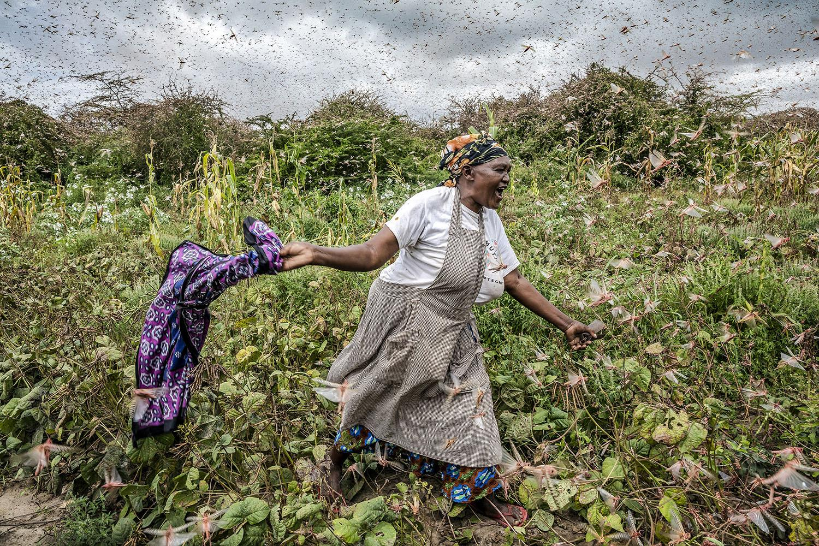

**Introduction**

Desert locust is the most destructive migratory pest in the world. Thriving in moist conditions in semi-arid to arid environments, millions of locusts have been feeding throughout East Africa, devouring everything in their path, posing an unprecedented threat to the food supply and livelihoods of millions of people.The fast-moving swarm is threatening crops in a country where more than 80 percent of the population depends on agriculture for its livelihood. Farmers stand by as armies of ravenous insects eat their young, healthy crops; meanwhile herders watch the rangelands stripped bare before their eyes, and before their livestock can get to them. Locust outbreaks happen intermittently, usually once every couple of decades, but this is the worst outbreak East Africa has witnessed since the late 1980s.

Scientists have linked the current outbreak to unusually favourable climate and resultant ecological conditions, both in Arabia and Eastern Africa regions, primarily driven by climate change. The extreme weather causing the intense rain storms in the area are believed to be caused by record high temperatures in the Indian Ocean Dipole, a phenomenon that caused extreme drought in Australia and torrential rain in East Africa. The U.S. Agency for International Development (USAID) has said it believes Climate Change (heavy rainfall) in East Africa has contributed to the growth of locust swarms in the area.

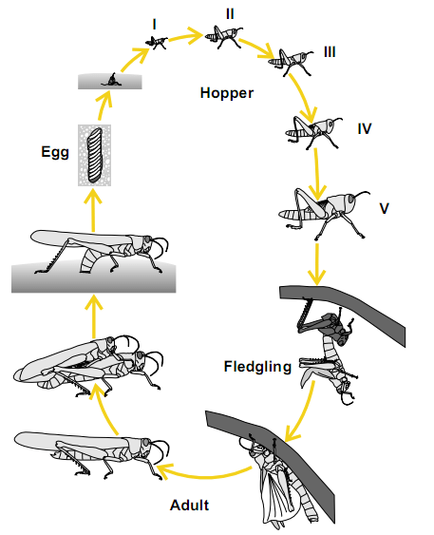

Fig 1.

The World Meteorological Organization and the U.N. Food and Agriculture Organization report that the life cycles of a locust--"the laying of eggs, egg development, hopper development, moulting, hardening of hopper wings, maturing of locusts, speed of movement of hopper bands and adult swarms, and transition from the younger, "solitary" phase to the gregarious (joining swarms) phase"--require ideal weather conditions including tail winds that facilitate their travel. The conditions this season have been unusually beneficial for breeding . Locusts breed after storms, laying as many as 1000 eggs in a square meter of sand. After hatching, the wingless nymphs travel in "hopper bands," literally long thick ribbons of insects that hop across the desert. They are hungriest in their "teen" years, and eat their weight in food every day, consuming almost any vegetation, including crops, pastures and forests.

Eventually, they grow into adults with wings and become "gregarious," traveling in large swarms. One square kilometer swarm can have from 40million-80million locusts, which eat about the same amount of food in one day as 35,000 people. An average swarm can destroy crops sufficient to feed 2,500 people for a year. Sometimes as many as 80 million locusts crowd into each square kilometer of the swarm, and they can travel more than 90 miles in a day (BBC). The **U.N. Food and Agriculture Organization** reports the insects destroyed more than **175,000 acres** of farmland in Somalia and Ethiopia by the end of December, 2020. The sheer size of the swarms in Kenya and Ethiopia give rise to great concern over even larger swarms during harvest season. An adult desert locust consumes food equaling roughly to its weight -- about two grams every day. That means that even a small swarm of insects will eat food consumed by six elephants, 20 camels, or 35,000 people every day, a devastating amount of destruction for local farmers, according to the FAO official.

**Food security at stake**

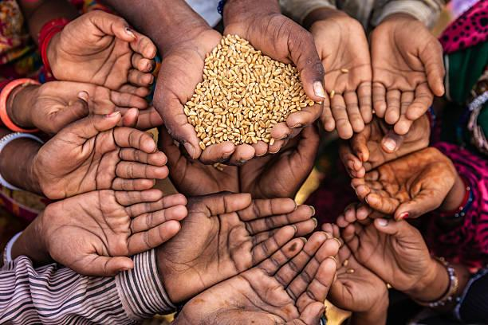

Populations across East Africa continue to experience severe levels of acute food insecurity, sustained and exacerbated by recurrent drought, seasonal flooding, conflict, and displacement. As such, locust-related damage to crops and pasture could have devastating effects on the food security and livelihoods of households in the region. The invasion poses an unprecedented threat to food security in the entire sub region, where more than 19 million people in East Africa are already experiencing a high degree of food insecurity (FAO). Locust outbreaks in East Africa put millions of vulnerable people at risk. The locust crisis will likely lead to a drop in agricultural production, further threatening food supplies in a region where 11.9 million people already suffer from food insecurity. The impact of desert locusts on food security could be the most devastating in countries that rely heavily on agriculture. The second wave of locusts, FAO warns, could endanger the food security of approximately 25 million people in East Africa. According to the latest Integrated Food Security Phase Classification (IPC) report, about 6.7 million people (in seven regions) are expected to be highly food insecure, in Crisis (IPC Phase 3). With the new wave of desert locusts, exacerbated by economic hardships resulting from COVID-19 restrictions, and flooding will likely amplify food insecurity unless urgent action is taken, to assist the affected communities.

On November 18, 2019, U.S. Ambassador Michael A. Raynor declared a disaster due to the impact of desert locust infestations in Ethiopia. On February 19, 2020, U.S. Chargé d’Affaires Brian Neubert declared a disaster for desert locust-affected areas of Somalia (Somalia, still plagued by insecurity), and on February 25, 2020, U.S. Ambassador Kyle McCarter issued a disaster declaration in Kenya due to the impacts of the pest across the country. U.S. Chargé d’Affaires Brian Shukan also declared a disaster due to the projected impact of uncontrolled infestations across Sudan on April 13, 2020.

The pandemic is also having a crippling economic effect in some of these countries, destroying jobs, dislocating trade systems and crimping supply lines through lockdowns and movement restrictions. The locust situation, meanwhile, is likely to get even worse. FAO warned a "massive increase" in locusts across the region would pose "an unprecedented threat to food security and livelihoods" by imperilling the upcoming planting and harvest seasons.

“The locust outbreak is the worst to strike Ethiopia and Somalia for 25 years and the worst infestation that Kenya had experienced in 70 years,” the director-general of the Food and Agriculture Organization (FAO), Qu Dongyu said in a statement:

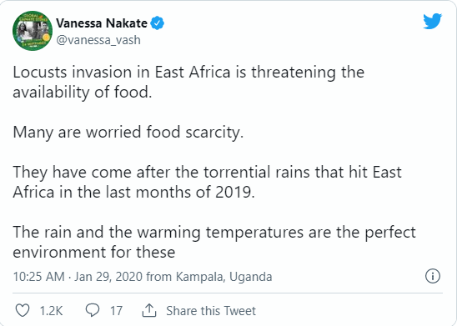

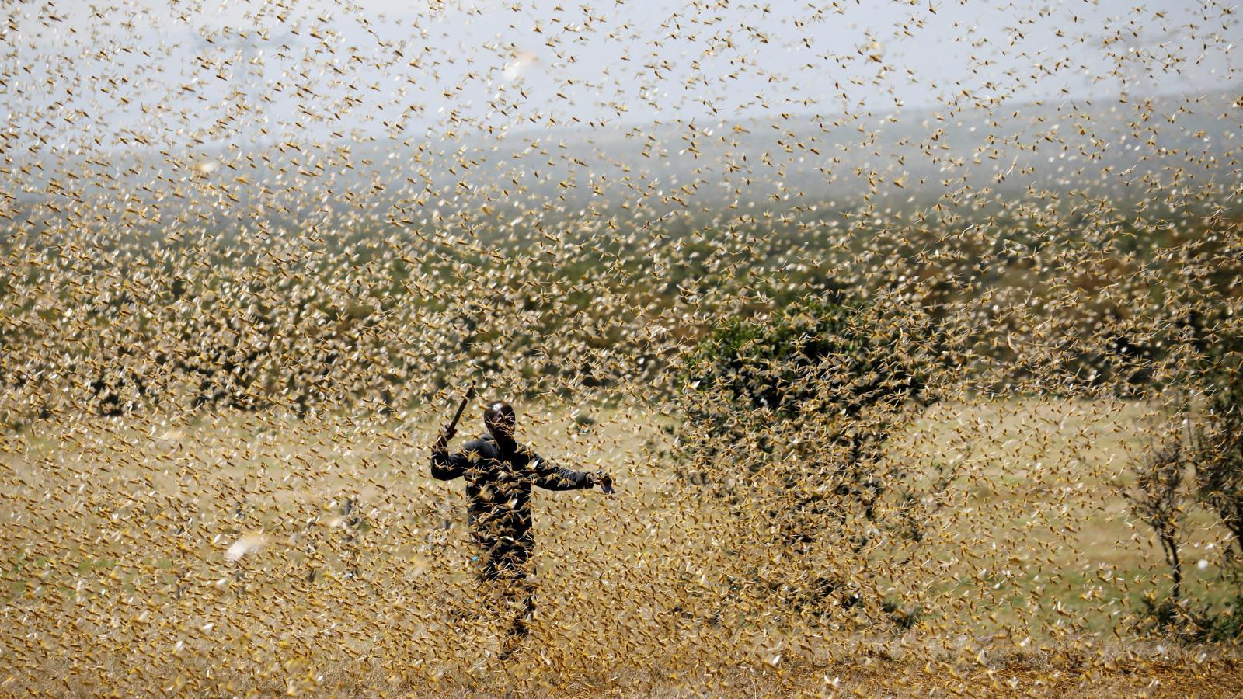

**Crops and Food Affected by Locust Invasion**

Massive swarms of desert locusts are invading east Africa, ravaging crops, decimating pasture and deepening a food crisis in a region where more than 25 million people are already hungry. FAO’s Desert Locust Information Service says it is the worst outbreak to strike Ethiopia and Somalia for 25 years and the worst infestation that Kenya has experienced in 70 years. Djibouti and Eritrea have also been affected, and locusts have been reported in South Sudan, Uganda and Tanzania and some East African Countries. Millions of people rely on agriculture and livestock rearing for their survival in this region.

Unfortunately, the worst of the outbreak may be yet to come, according to the Food and Agriculture Organization of the United Nations. The potential threat to food security and livelihood in the region is unprecedented. In a country like **Ethiopia 80%** of the country relies on agriculture. In **Kenya, 75%** of the population relies on agricultural activities. These locusts are attacking crops and can have extremely devastating consequences on populations that are already vulnerable. According to the latest predictions, the locust infestation in East Africa could drive more than 13 million people deeper into a hunger crisis and increase the risk that more children will die from malnutrition.

* **Maize**

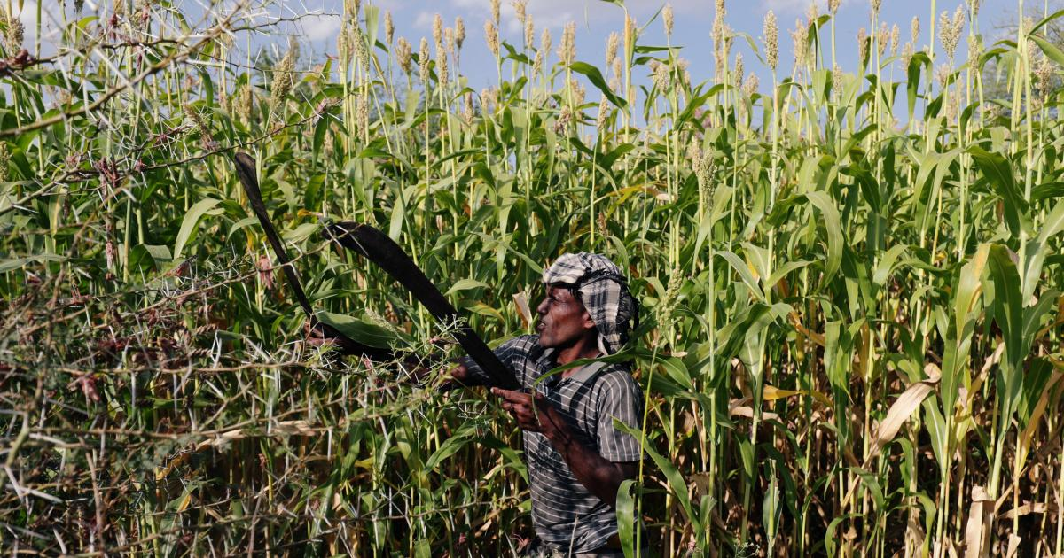

Maize is by far the most important cereal crop in the four largest countries of eastern Africa. Combined production of **17.2 million tonnes in 2016**, despite ongoing drought, is nearly 50% more than a decade ago. Remove middle-income Kenya, which had a 14% decline, and the increase for Ethiopia, Tanzania and Uganda was nearly 70% versus population growth since 2006 of 27%. A presentation at the 2015 International Association of Operative Millers Conference in Nairobi cited recent studies showing average ppms in the region far above international norms. Along with food safety, the dominance of smallholder farmers, government market intervention, regional trade and food security are all key aspects of the maize economy in eastern Africa as examined country by country.

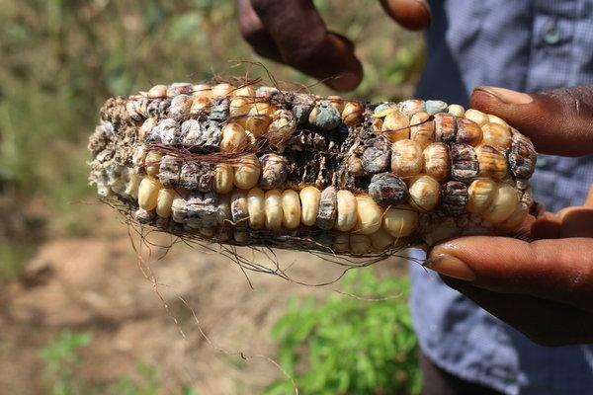

The first-wave of infestations at the end of 2019 destroyed **70,000 ha of farmland in Somalia** and **Ethiopia**, and **2,400 km of pasture land in Kenya**. A recent assessment in Ethiopia estimated that between December 2019 and March 2020, locusts damaged **41,000 ha of maize**, according to ICPAC. In Ethiopia, locust infestations will likely contribute to significant decreases in agricultural production by September, further exacerbating food insecurity and malnutrition across the country, according to the UN. Individuals residing in locust-affected areas—many of whom had limited to no household cereal stocks following the below-average October To-December Meher harvests in 2019—are already increasingly employing negative coping strategies to meet basic needs. For example, a February interagency assessment recorded instances of people selling livestock, as well as reducing household expenditures on seeds, tools, and other agricultural and livestock inputs.

* **Plantain / Banana**

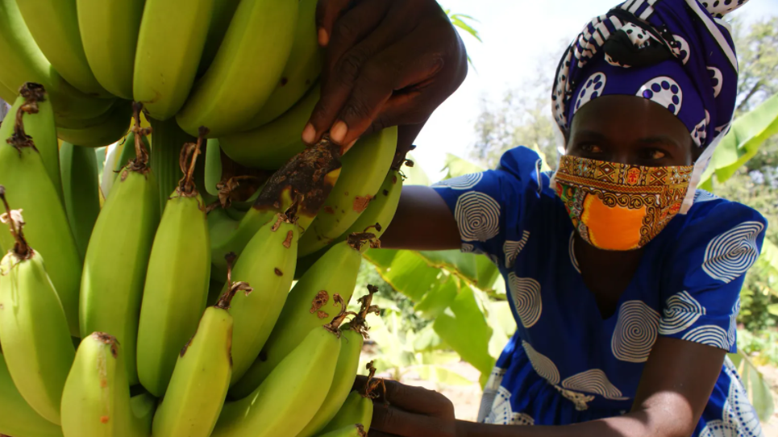

Plantain is one of the major fruits for consumption and for commercials in East Africa, The high amount of potassium found in plantains is essential for maintaining the cell and body fluids that control your heart rate and blood pressure. The fiber in plantains also helps lower your cholesterol, which in turn keeps your heart functioning at its best.

The proportion of households reporting poor food consumption deteriorated from **37%** in August 2019 to **41%** in February 2020. Afar region recorded the highest proportion of households with poor consumption, at **91%** in February 2020 compared to **58%** in August 2019. In the Oromia region, the proportion of households reporting poor food consumption increased from **38%** in August 2019 to **50%** in February 2020. In the seven days prior to the assessment, about two thirds of the households reported consuming less than three food groups compared to seven as recommended by nutrition experts. This means the nutrition for the household members is compromised. Up to **97%** of households in Afar and **74%** in both Somali and Oromia consumed three or fewer food groups.

* **Herders (Livestocks, RangeLands) :**

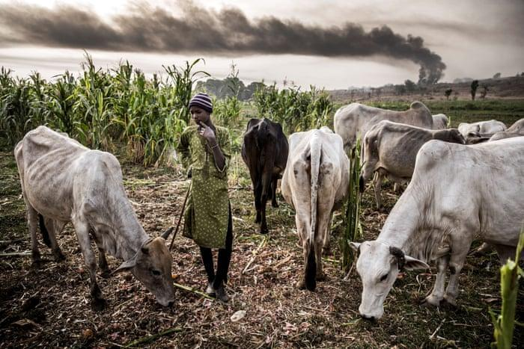

This has totally affected the grazing land and can easily lead to conflict and insecurity with communities around and within, as each will start fighting for pasture for their animals. The locusts have destroyed all of the grazing land, and herders are very worried that their livestock will starve and die because these locusts are everywhere and are taking over the whole area. And within a year, the locusts destroyed over 170,000 acres of land in Somalia and Ethiopia — where people rely on crops for food and income.

Communities in Kenya are concerned that a final generation of locusts, after the end of the rainy season, will destroy the rangeland, leaving cattle, donkeys, goats, and camels to starve to death.

The insects have also pushed herders to non-traditional grazing lands – a challenge in itself due to coronavirus lockdowns and curfews – often leaving women behind to feed children. This sometimes leads to violent clashes with farmers, adding to disputes of the sort that have left more than **9,000** people dead in Nigeria’s arid Middle Belt since 2011.

* **Millet**

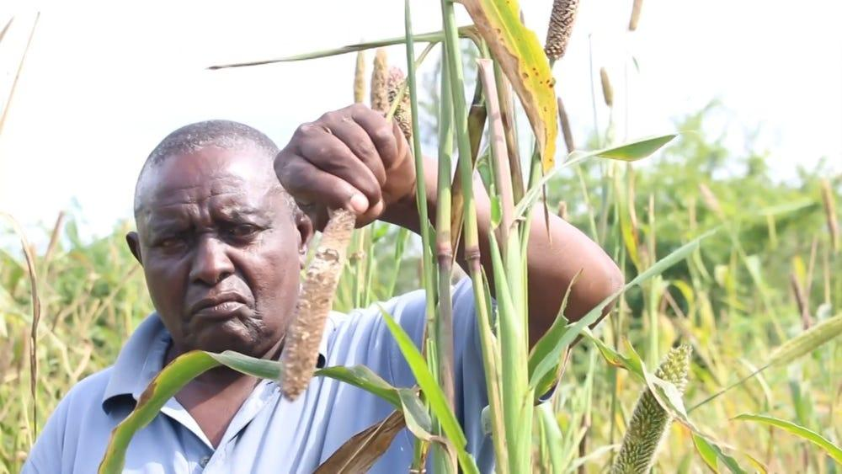

Another crop that the desert locust destroys is Millets, these are small-grained, annual, warm-weather cereals belonging to the grass family, they are a group of highly variable small-seeded grasses, widely grown around the world as cereal crops or grains for fodder and human food. Millets are important crops in the semiarid tropics of Asia and Africa, with **97%** of millet production in developing countries. Millet, which is used for different things, is indigenous to many parts of the world. The most widely grown millet is pearl millet, which is an important crop in India and parts of Africa. In 2016, global production of millet was **28.4 million tonnes**, led by India with **36%** of the world total. Niger also had significant production.

**Uses:**

* **Alcoholic beverages :** In India, various alcoholic beverages are produced from millets. Millet is also the base ingredient for the distilled liquor rakshi.
* **As a food source :** Per capita consumption of millets as food varies in different parts of the world, with consumption being the highest in Western Africa. In the Sahel region, millet is estimated to account for about 35% of total cereal food consumption in Burkina Faso, Chad and the Gambia. In Mali and Senegal, millets constitute roughly 40% of total cereal food consumption per capita, while in Niger and arid Namibia it is over 65%. Other countries in Africa where millets are a significant food source include Ethiopia, Nigeria and Uganda. Millet is also an important food item for the population living in the drier parts of many other countries, especially in eastern and central Africa, and in the northern coastal countries of western Africa. In developing countries outside Africa, millet has local significance as a food in parts of some countries, such as China, India, Burma and North Korea. Millet porridge is a traditional food in Russian, German, and Chinese сuisines. In Russia, it is eaten sweet (with milk and sugar added at the end of the cooking process) or savoury with meat or vegetable stews. In China, it is eaten without milk or sugar, frequently with beans, sweet potato, and/or various types of squash. In Germany, it is also eaten sweet, boiled in water with apples added during the boiling process and honey added during the cooling process. Millet is also the main ingredient in a Vietnamese sweet snack. It contains a layer of smashed millet and mung bean topped with sliced dried coconut meat wrapped in a crunchy rice cake. It is a specialty of Hanoi.
* **Grazing Millet** : In addition to being used for seed, millet is also used as a grazing forage crop. Instead of letting the plant reach maturity, it can be grazed by stock and is commonly used for sheep and cattle.

Countries and regions suffering locust infestation tend to be badly affected and suffer from millet shortage both for consumption and commercial purposes.

* **Rice**.

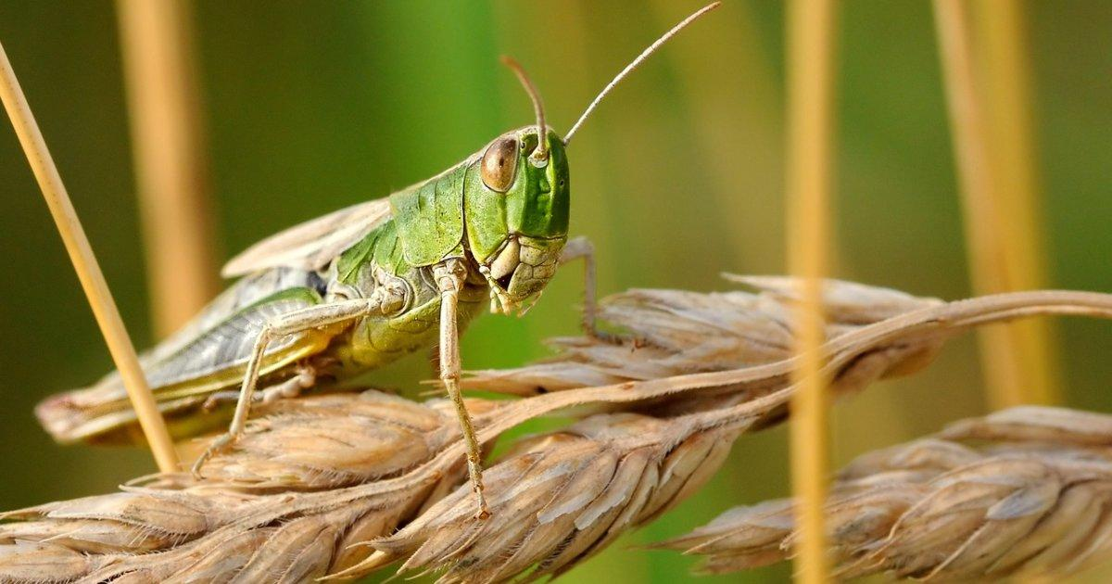

Agriculture contributes immensely to the GDP of East African countries where locust infestation has been a major threat to Agricultural activities and food production. One of the major crops that is majorly affected by this insect is **Rice.** Rice is a staple food in many countries of Africa and constitutes a major part of the diet in many others. During the past three decades the crop has seen consistent increases in demand and its growing importance is evident in the strategic food security planning policies of many countries. Africa's inability to reach self-sufficiency in rice is the result of several major constraints in the rice industry which require urgent redress to stem the trend of over-reliance on imports and to satisfy the increasing demand for rice in areas where the potential of local production resources is exploited at very low levels.

Rice is a major food staple and a mainstay for the rural population and their food security. It is mainly cultivated by small farmers in holdings of less than one hectare. Rice is also a wage commodity for workers in the cash crop or non-agricultural sectors. Rice is vital for the nutrition of much of the population in Asia, as well as in Latin America and the Caribbean and in Africa; it is central to the food security of over half the world population.

Africa produces an average of **14.6 million tonnes** of rough rice per year (1989-1996) on 7.3 million ha, equivalent to 2.6 and 4.6 percent of the world's total production and rice area, respectively. Africa consumes 11.5 million tonnes of rice per year (FAO, 1996), 33.6 percent of which is imported, while East Africa tend to import less Rice, which indicates that their major consumption comes from their local production which in recent times is affected by locust infestation hence inflicting more hunger in most countries in this region.

* **Barley**

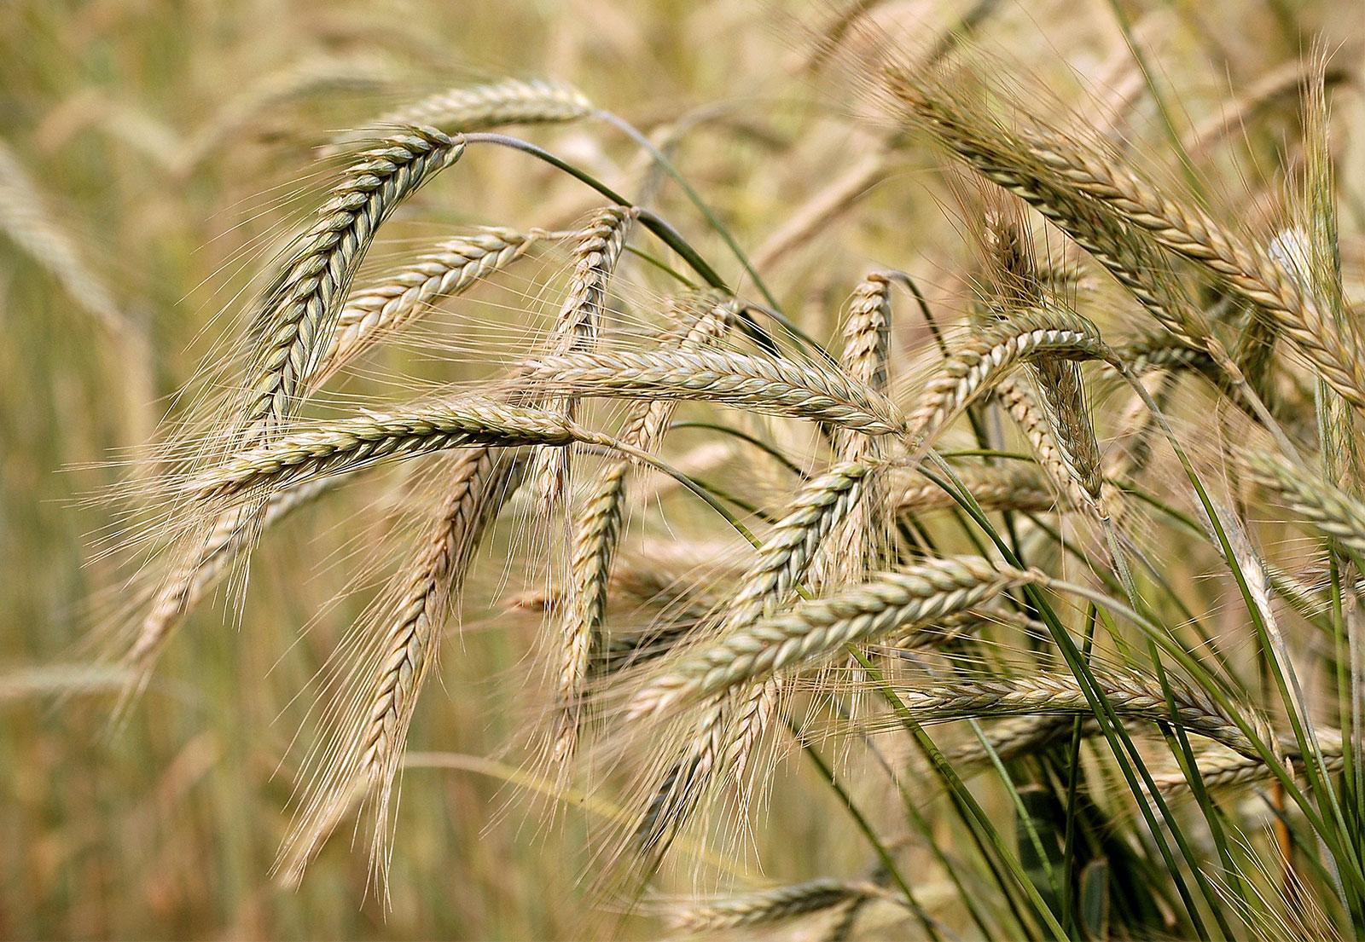

Barley is a cereal grain that people can use in bread, beverages, stews, and other dishes. As a whole grain, barley provides fiber, vitamins, and minerals. These offer various health benefits. Barley, (Hordeum vulgare), cereal plant of the grass family Poaceae and its edible grain. Grown in a variety of environments, barley is the fourth largest grain crop globally, after wheat, rice, and corn. Barley is commonly used in breads, soups, stews, and health products, though it is primarily grown as animal fodder and as a source of malt for alcoholic beverages, especially beer.

* **Sorghum**

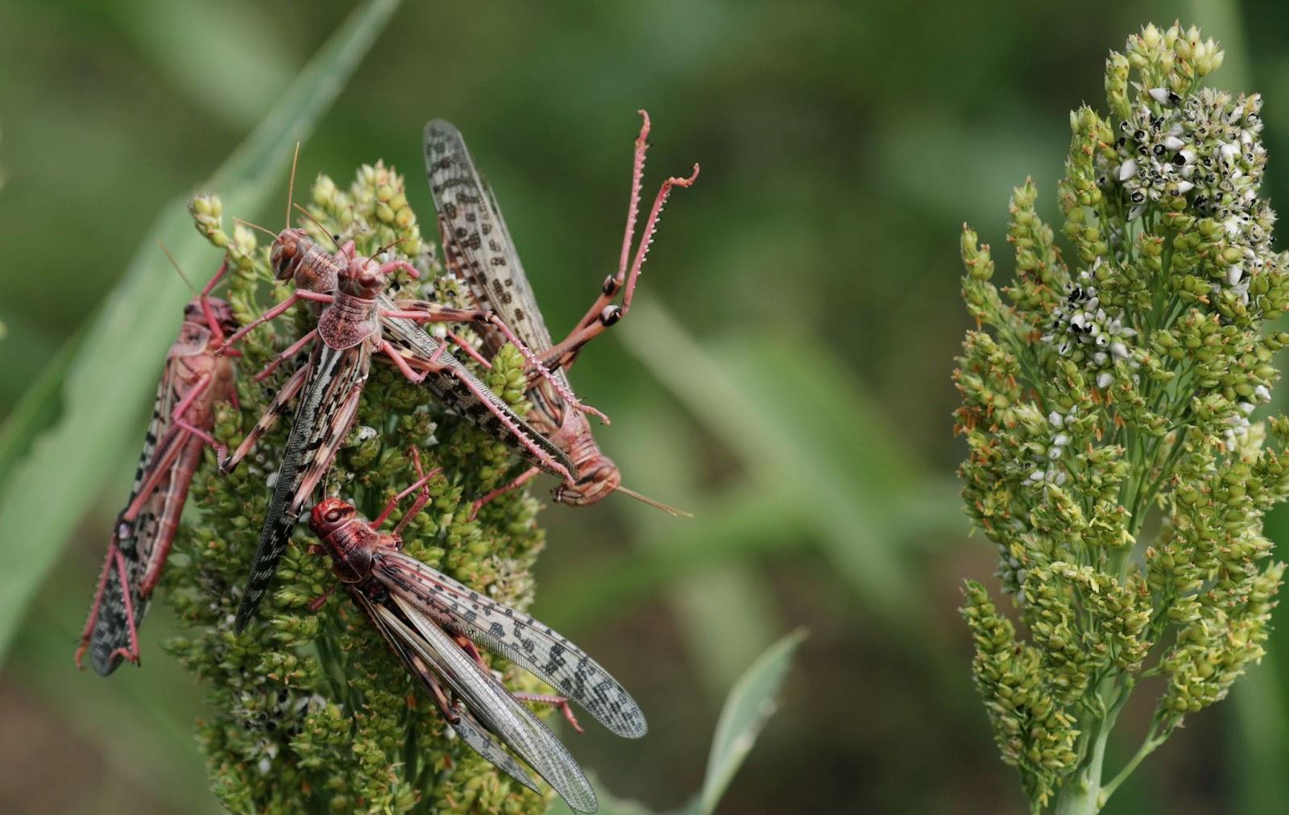

A recent assessment in Ethiopia estimated that between December 2019 and March 2020, locusts damaged 114,000 of Sorghum. Sorghum is an ancient cereal grain belonging to the grass family Poaceae. It's small, round, and usually white or yellow — though some varieties are red, brown, black, or purple. Sorghum is a versatile cereal grain used for human consumption as well as livestock feed, alcoholic beverages, and biofuel production. When sorghum is consumed with its outer hull intact, it's a good source of dietary fiber and antioxidants.

Sorghum is an important staple food in East Africa. Domestic sorghum production makes important contributions to national food supply in Sudan, Somalia, and South Sudan (39, 54 and 76 percent, respectively), and smaller amounts in Ethiopia and Uganda (17 and 10 percent, respectively).

* **Wheat**

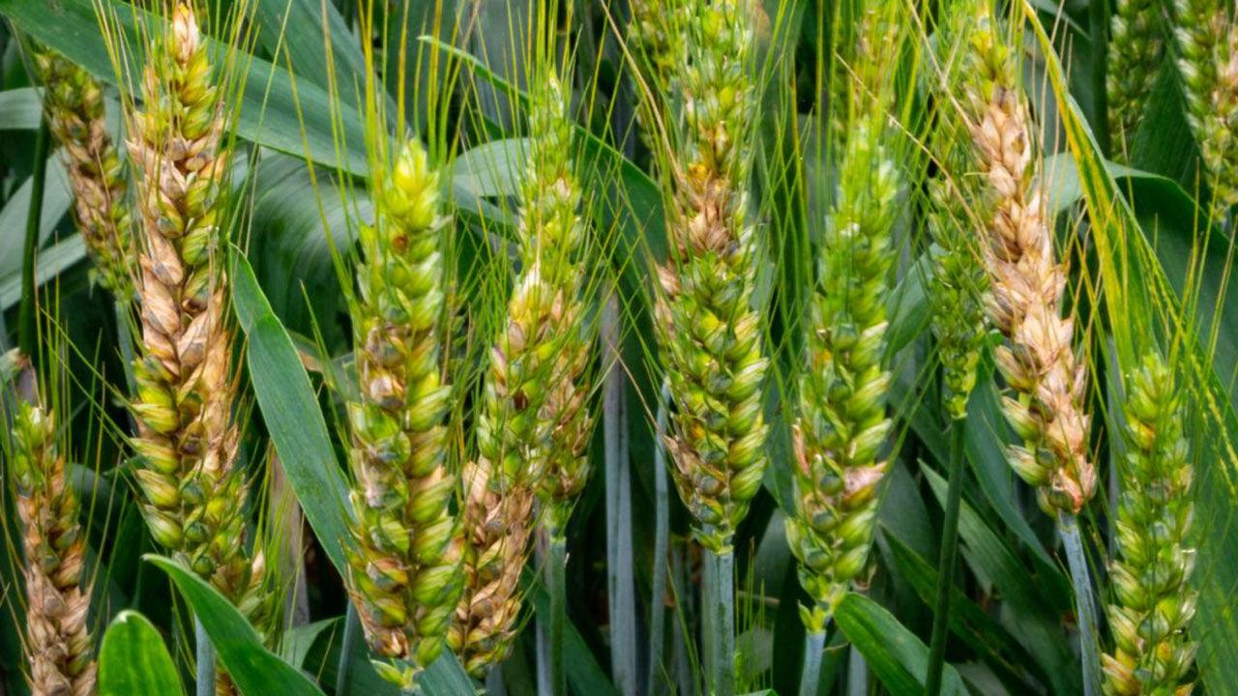

A recent assessment in Ethiopia estimated that between December 2019 and March 2020, locusts damaged 36,000 ha of Wheat. Wheat is one of the world's most commonly consumed cereal grains. It comes from a type of grass (Triticum) that is grown in countless varieties worldwide. Bread wheat, or common wheat, is the primary species. Other wheat-based foods include pasta, noodles, semolina, bulgur, and couscous.

Other crops include but not limited to the following:

* Coffee
* Cotton
* Cowpeas
* Green grams

**Economic Impact**

Meanwhile, hits to farmer livelihoods have escalated into macroeconomic shocks. Key financial indicators like real GDP growth, revenue, exports, and possibly debt are being impacted negatively by the locust swarms. Lower agriculture contribution to GDP growth will dampen government revenue generation capacity at a time when financial market volatility is already constraining liquidity and creating funding challenges. The swarms will test limited food stocks in the fragile region, add to public debt, remove a vital economic driver and exacerbate inflationary pressure exerted by Covid-19 related export cuts and panic buying. That could cheapen regional currencies and prevent East African countries from paying off external debt stocks. All that is a recipe for political insecurity, Countries in the Horn have quite fragile political situations. The desert locusts are an added layer that could lead towards tipping the balance towards conflict. Ethiopia has experienced an uptick in ethnonational violence, with the swarms adding to stress levels.

The impact of desert locusts on food security could be the most devastating in countries that rely heavily on agriculture. For instance, 75% of the population in Kenya earns income from agriculture, which generates one-third of the country’s gross domestic product (GDP). Similarly, agriculture accounts for 40% of the GDP, 80% of exports, and 75% of the workforce in Ethiopia. In such countries, the second wave of locusts is likely to harm both the economy and food security.

Ethiopia’s economy is dependent on agriculture, which accounts for 40 percent of the GDP, 80 percent of exports, and an estimated 75 percent of the country's workforce. Major cash crops include coffee, maize, pulses, oilseeds, sorghum, and cereals. In 2018/2019, Ethiopia's major goods exports included **coffee** (28.7%), oilseeds (14.5%), chat (11.4%), pulses (10.2%), cut flowers (9.6%), leather and leather products (4.4%) and gold (1%).

As a result of unusually hot weather and heavy rains caused by climate change, the largest swarm of giant locusts seen in almost three-quarters of a century are destroying crops across east Africa, central Asia and the Middle East, putting as many as 20 million people at risk of “an unprecedented threat to food security and livelihoods at the beginning of the upcoming cropping season.”- Food and Agriculture Organisation of the United Nations (FAO).

One February evening, a farmer, Samuel Mwangi watched as a swarm of desert locusts arrived and sat on the trees near his farm at Kariara village, in Kenya’s eastern Tharaka Nithi County. The next morning, they began destroying crops on his seven acres of land as he looked on helplessly from a distance, full of despair after several failed attempts to drive the locusts away. “Here on my farm, they worked on my maize, coffee and beans as I have never seen before,” the 61-year-old father of eight tells *Equal Times*.

The agricultural sector is the backbone of the economy, contributing **approximately 33 percent of** Kenya's Gross Domestic Product (GDP).

The current locust infestation began in June 2019 and has its genesis in heavy rains that hit the Arabian Peninsula in 2018, allowing for abnormally high levels of breeding. By the summer of 2019, swarms of locusts had crossed over to Ethiopia (B/Negative) and Somalia, where additional abnormal weather led to even higher rates of reproduction. According to the UN Food and Agriculture Organization, locust swarms have already damaged almost 2% of Ethiopia's croplands, in what is the country's worst infestation in 17 years. Swarms are currently also infesting the northern districts of both Kenya (B+/Stable) and Uganda (B+/Stable). New swarms will be breeding throughout June, just in time for the July harvest season. A relationship between heavy rainfall and the influx and infestation of locust swarms in arid regions has been established by several researchers over the years.

**Slows pace of the economy**

Experts fear that locust swarms will hit the country’s GDP figures immensely. Expecting a good agriculture yield, Ethiopian Prime Minister Abiy Ahmed had last month projected 6.1% growth for the current financial year. Since agriculture contributes to a lion’s share in the GDP, its slowing down is expected to have cascading effects on overall economic progress.

* **Desert locusts in East Africa: A plague of another order (**[**https://reliefweb.int/report/ethiopia/desert-locusts-east-africa-plague-another-order**](https://reliefweb.int/report/ethiopia/desert-locusts-east-africa-plague-another-order)**)**
* <https://medium.com/@icpac/desert-locust-invasion-in-eastern-africa-c3ae3918717c>
* **Ethiopia: Worst locust outbreak in 25 years (**[**https://www.aa.com.tr/en/africa/ethiopia-worst-locust-outbreak-in-25-years/2031673#**](https://www.aa.com.tr/en/africa/ethiopia-worst-locust-outbreak-in-25-years/2031673#)**)**
* [**https://africa.businessinsider.com/video/a-swarm-of-locusts-of-biblical-proportions-is-threatening-the-food-supply-of-20/n49lqvz**](https://africa.businessinsider.com/video/a-swarm-of-locusts-of-biblical-proportions-is-threatening-the-food-supply-of-20/n49lqvz)
* [**https://www.allaboutfeed.net/animal-feed/raw-materials/locusts-decimate-crops-in-east-africa/**](https://www.allaboutfeed.net/animal-feed/raw-materials/locusts-decimate-crops-in-east-africa/)
* [**https://www.actionagainsthunger.org/story/locusts-swarm-east-africa**](https://www.actionagainsthunger.org/story/locusts-swarm-east-africa)
* [**https://www.newsecuritybeat.org/2020/05/plague-ravenous-locusts-descends-east-africa-jeopardizes-food-security/**](https://www.newsecuritybeat.org/2020/05/plague-ravenous-locusts-descends-east-africa-jeopardizes-food-security/)

**ANALYSIS AND METHODOLOGY BREAKDOWN**

**ABSTRACT**

Using Autoregressive Integrated moving average (**ARIMA**) modelling, A time series of the monthly number of **0.050 x 0.050**resolution satellite grid squares infested with desert locust (Schistocera gregaria) Swarms throughout the Ethiopian regions from **1987** to **2021** was analyzed. Grid squares with no rainfall value were removed, and analysis was carried out on grid squares with rainfall values. The rainfall values were extracted into time series ranging from 1987 to 2021 across over 2400 stations. A square-root transformation for the locust data was performed and the addition of rainfall data as an exogenous variable improved the fit. The models were only partially successful when accounting for the dramatic changes in abundance which may occur during Locust upsurges and declines, in some cases successfully predicting these phenomena but underestimating their exactingness. The results are examined in the context of predicting the likely changes in desert Locust dynamics with regards to future effects of Climate Change.

**PROBLEM STATEMENT**

The study of Desert Locusts behavioural patterns in relation to changing meteorological and climatic conditions and a call to adapt control and preparedness plans has over the years attracted more attention as this can be a major factor to famines and poses a great threat to food security in different regions of the World. Locust breeding and movements seem unpredictable, movement over wide areas in one country can rapidly affect events in others, which makes it an international responsibility.

Desert Locusts, which mostly includes short-horned grasshoppers, are members of the grasshopper family **Acrididae.** They have the ability to change their behaviour and physiology, as well as their color and shape (morphology) in response to change in density. Adult locusts can form Swarms that may contain millions or billions of individuals that behave as a coherent unit. When green vegetation and plentiful rainfalls develop, Desert Locusts tend to increase in number and within a few months, start to concentrate and become gregarious (behave as a single unit). This is called an **Outbreak** and usually occurs within an area of about 500km2 . Outbreaks when not controlled can evolve into an upsurge if unusually heavy rain falls in adjacent areas, creating favourable breeding conditions. When ecological conditions remain favourable for breeding and upsurge not well controlled, locusts continue to increase as gregarious bands or swarms, then a plague can develop, which affects two or more regions.

The **FAO (Food and Agricultural organization)** is the lead agency in Desert locust monitoring and control and runs the **Desert Locust Information Service (DLIS)**. All Locust-affected countries transmit locust and environmental data, as well as survey and control results to DLIS for analysis, in conjunction with weather and habitat data and satellite imagery, in order to assess the current locust situation, provide forecasts of up to six weeks and issue early warnings.

Desert Locust has the potential to damage the livelihoods of one tenth of the world's population, this has drawn the World’s attention to the threat they pose to the food security of the most affected countries, especially in the developing world. This problem calls for an integrated approach to understanding the conditions that lead to the locust build-up and their migration so that effective solutions can be developed for controlling damage.

**INTRODUCTION**

Increasing temperatures and sea levels, changing precipitation patterns and more extreme weather are threatening human health and safety, food and water security and socio-economic development. “Climate change is having a growing impact on the African continent, hitting the most vulnerable hardest, and contributing to food insecurity, population displacement and stress on water resources. In recent months we have seen devastating floods, an invasion of desert locusts. The human and economic toll has been aggravated by the COVID-19 pandemic,” said WMO Secretary-General Petteri Taalas. Predictions of how climate change will affect rainfall in the Sahara Desert are varied and lack consensus. The name Sahel refers to the semi-arid region stretching longitudinally from Senegal in West Africa to Sudan and Ethiopia in East Africa and latitudinally from just north of the tropical forests to just south of the Sahara desert (roughly between 10° and 20°N). In the remote (Shanahan et al., 2009) and recent (Nicholson, Fink, & Funk, 2018) past rainfall in the Sahel has undergone profound changes and more changes of the same magnitude are expected for the near future (Chadwick, Good, Martin, & Rowell, 2016). However, for farther south, the IPCC report stated that it is unclear how rainfall in the Sahel, the Guinean Coast and the southern Sahara will evolve. There are some indications that, for instance in the Sahel, rainfall may increase as a result of increasing carbon dioxide levels leading to enhanced vegetation growth and moisture levels (Claussen

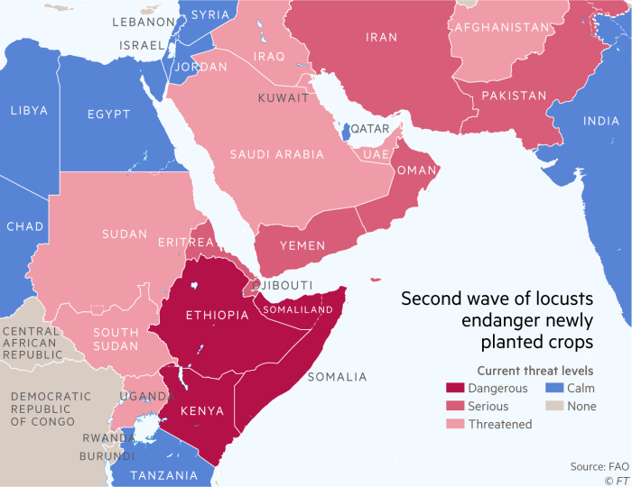

Fig 1.

et al. 2003). If the latter happens to be the case, this may lead to increased recurrence of outbreaks of the desert locust *Schistocerca gregaria,* since desert Locust nearly always lays its eggs in soil that is wet enough to allow the eggs to absorb sufficient moisture to complete their development. Eggs are rarely laid in dry or nearly dry soil.If eggs were laid in a dry soil, they would desiccate (dry out) unless rain fell soon after laying. The rate of development is therefore exclusively a function of the soil temperature at pod depth. There is a reasonably good relationship between soil temperature and screen (air) temperature so rates of egg development can be predicted satisfactorily from air temperatures and even from long-term mean values since temperatures do not vary greatly between years for a given place and time of year in most of the breeding areas. However, there can be exceptions to this, notably during the winter when the weather may be unusually warm, allowing development to continue. It is always possible to find a warm enough wind from approximately the right direction to explain why a particular swarm migration has occurred. Solitarious locusts, like swarms, persist after fledging if there is lush green vegetation. When migration does occur, it may take place over a series of nights, where they fly and feed on green vegetation and breed when mature. Predictions of what is likely to happen, even with a quantitative rainfall link, are difficult and will need to take account of spatiotemporal variation.

Similarly with other locusts, the desert locust exhibits 2 distinct behavioural phases, the Solitary and Gregarious phase type of polyphenism. Solitary locusts, nymphs and adults can behave gregariously within a few hours of being placed in a crowded situation, while gregarious locusts need one or more generations to become solitary when reared in isolation. Differences in morphology and behaviour are seen between the two phases. In the solitary phase, the hoppers do not group together into bands but move about independently. Their colouring in the later instars tends to be greenish or brownish to match the colour of their surrounding vegetation. The adults fly at night and are also coloured so as to blend into their surroundings, the immature adults being grey or beige and the mature adults being a pale yellowish colour. In the gregarious phase, the hoppers bunch together and in the later instars develop a bold colouring with black markings on a yellow background. The immatures are pink and the mature adults are bright yellow and fly during the day in dense swarms. The change from an innocuous solitary insect to a voracious gregarious one normally follows a period of drought, when rain falls and vegetation flushes occur in major desert locust breeding locations. The population builds up rapidly and the competition for food increases. Changes from the solitary to the

gregarious phase are the result of a complex interaction of factors—including high rainfall allowing high survival rates, the type and distribution of the vegetation (Babah & Sword 2004), and behaviour, with the factor that finally leads to the change being an increase in the rate at which hairs on the locusts’ back legs are touched by other locusts in a group (Simpson et al. 2001).

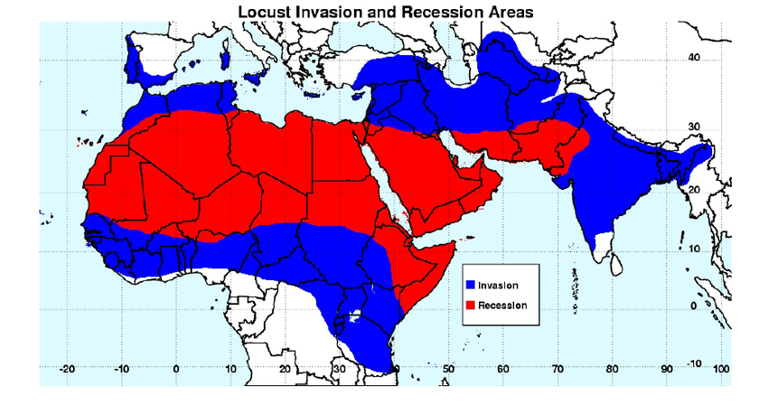

Fig 2.

As hoppers get more crowded, the close physical contact causes the insects' hind legs to bump against one another. This stimulus triggers a cascade of metabolic and behavioral changes that causes the insects to transform from the solitary to the gregarious phase. When the hoppers become gregarious, their colouration changes from largely green to yellow and black, and the adults change from brown to pink (immature) or yellow (mature). Their bodies become shorter, and they give off a pheromone that causes them to be attracted to each other, enhancing hopper band and subsequently swarm formation. The nymphal pheromone is different from the adult one. When exposed to the adult pheromone, hoppers become confused and disoriented, because they can apparently no longer "smell" each other, though the visual and tactile stimuli remain. After a few days, the hopper bands disintegrate and those that escape predation become solitary again. This effect could aid locust control in the future. During quiet periods, called recessions, desert locusts are confined to a 16-million-km2 belt that extends from Mauritania through the Sahara Desert in northern Africa, across the Arabian Peninsula, and into northwest India. Under optimal ecological and climatic conditions, several successive generations can occur, causing swarms to form and invade countries on all sides of the recession area, as far north as Spain and Russia, as far south as Nigeria and Kenya, and as far east as India and southwest Asia. As many as 60 countries can be affected within an area of 32 million km2, or about 20% of the Earth's land surface.

Locust swarms fly with the wind at roughly the speed of the wind. They can cover from 100 to 200 km (62 to 124 mi) in a day, and fly up to about 2,000 m (6500 ft) above sea level (the temperature becomes too cold at higher altitudes). Therefore, swarms cannot cross tall mountain ranges such as the Atlas, the Hindu Kush, or the Himalayas. They do not venture into the rainforests of Africa nor into central Europe. However, locust adults and swarms regularly cross the Red Sea between Africa and the Arabian Peninsula, and are even reported to have crossed the Atlantic Ocean from Africa to the Caribbean in 10 days during the 1987-89 plague. A single swarm can cover up to 1200 km2 and can contain between 40 and 80 million locusts per km2 (a total of around 50 to 100 billion locusts per swarm, representing 100,000 to 200,000 tons, considering an average mass of 2 g per locust). The locust can live between 3 and 6 months, and a 10- to 16-fold increase in locust numbers occurs from one generation to the next.

In spite of the fact that many non-statistical case studies have been conducted on historical examples of migration and breeding sequences in the desert locust, few studies have applied statistical modelling to the large-scale spatio-temporal dynamics of the species. Data from the the FAO

SWARMS dataset which is available on the FAO website database. This database is a compilation of observations recorded by an extensive network of locust control personnel over a 40yr period (1981 – 2021) (As of the time this paper was written), gridded at 1° resolution. As such, it constitutes the most spatio-temporally complete information for any insect pest, with 40yr of daily data at 1° resolution covering the entire geographical range of the species (Magor & Pender 1997).

Using autoregressive integrated moving average (ARIMA) models, we analysed monthly data on the number of **0.05° × 0.05°** grid squares with reported swarms of desert locusts during the period **1981 to May 2021**. We examined the dynamics of the locust data alone and then incorporated an index of monthly rainfall into the analyses. Through this we tested whether it is possible to predict locust plagues using endogenous data alone or if there is a need to incorporate rainfall data into the modelling process to produce realistic forecasts. If the latter proved to be necessary, then it would form the basis for future tests of how predicted rainfall changes under future climate change scenarios might affect locust abundance.

**ANALYSIS**

**Data Acquisition and Extraction**

Rainfall data, sourced from the Climate Hazards Group Infrared Precipitation with Stations (CHIRPS), developed by the Climate Hazards Group of University of California was used. It can be accessed at <https://data.chc.ucsb.edu/products/CHIRPS-2.0/>. The CHIRPS dataset is a quasi-global rainfall dataset covering 50° S to 50° N and spanning from 1981 to near present, as it gets updated regularly. It incorporates 0.05° × 0.05° resolution satellite imagery with in situ station data to create gridded rainfall time series suitable for trend analysis and seasonal drought monitoring. It is originally computed in a pentad (5 days), and all other time steps are either aggregated (decadal and monthly) or disaggregated (daily).

Locust data was sourced from the locust hub of FAO which can be accessed at <https://locust-hub-hqfao.hub.arcgis.com/>.

Rainfall data was added to the loust data as an exogenous variable in correspondence with specific X and Y coordinates and dates with respect to Ethiopia. Approximately 2400 locations were recorded over specific days of rainfall which amounted to 3343 data points.

**Data Extraction**

Gridded rainfall data is stored as raster files with coordinates and respective rainfall values stored in each grid. The respective rainfall values for selected coordinates were extracted from 1981 to May 2021 and stored as time series. This was achieved using Python libraries as tutored by Geodelta Labs.

The first step is to import the required Python libraries.

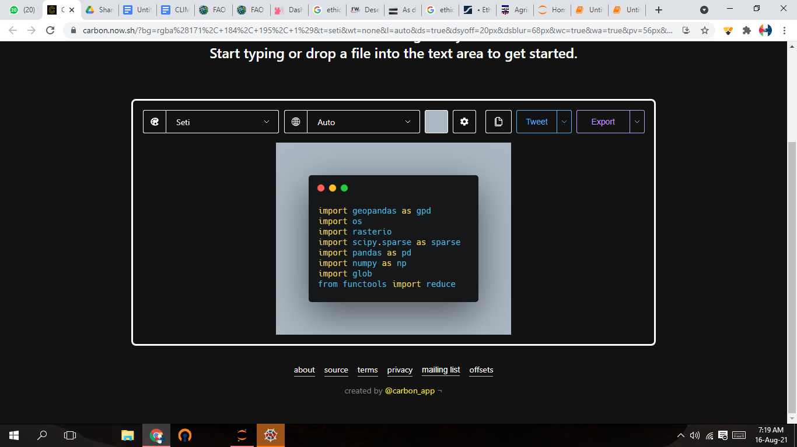

In order to specify the needed coordinates for extraction, it is necessary to store them in a shapefile format. The shapefile was obtained from the locust data website.

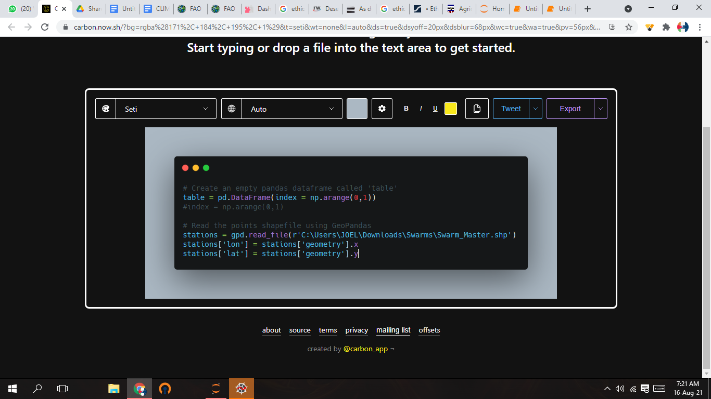

The locust data contained data for the whole of Africa. Ethiopia is the region of reference to be analysed

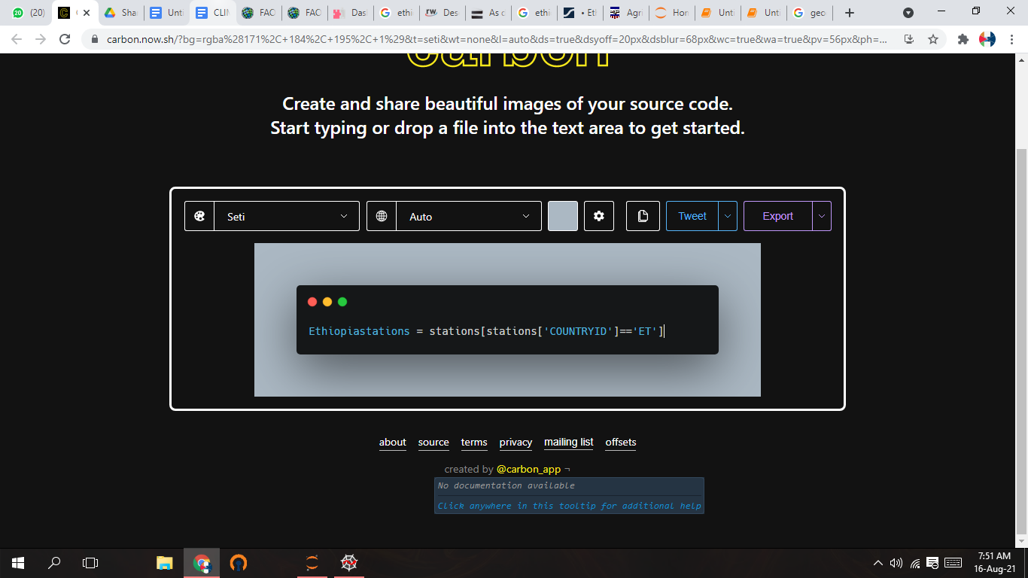

The respective data was stored in batches of four years each in different folders. This is necessary to manage compute time and resources due to the large size of each raster file, covering the region of Africa.

Each raster is read individually and the respective rainfall values for each coordinate is stored as an array subsequently stored as a matrix.

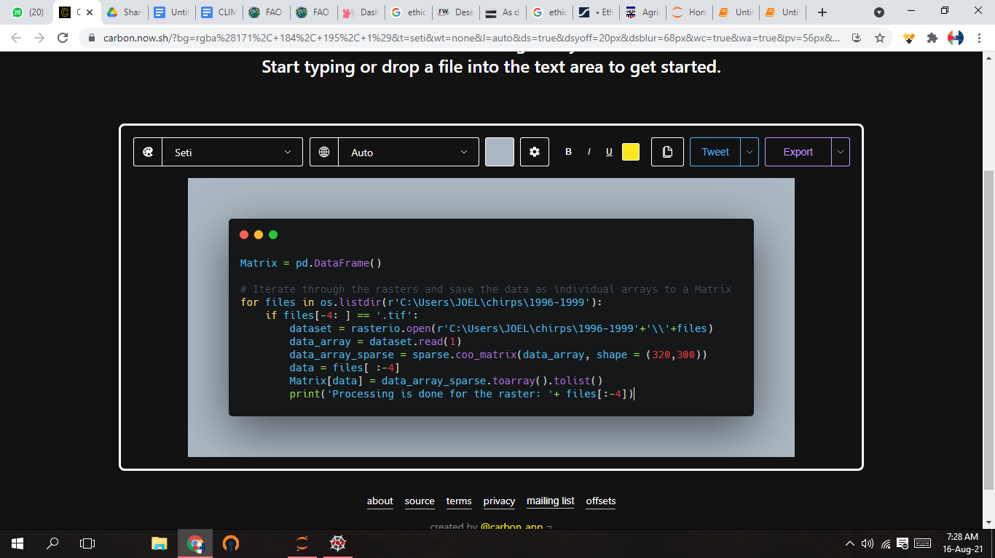

The selected coordinates for the region of Ethiopia are read through and the rainfall values for each day per station is picked and saved as a time series csv file. This will result in numerous csv files representing each location.

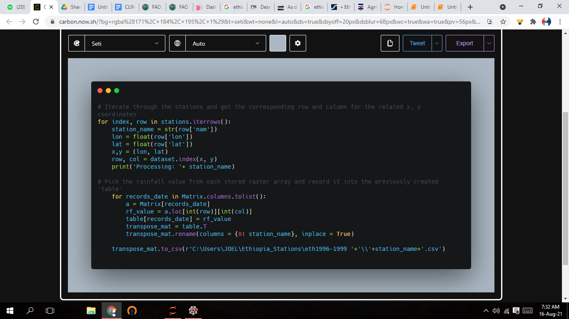

The csv files are then merged together to form one csv file.

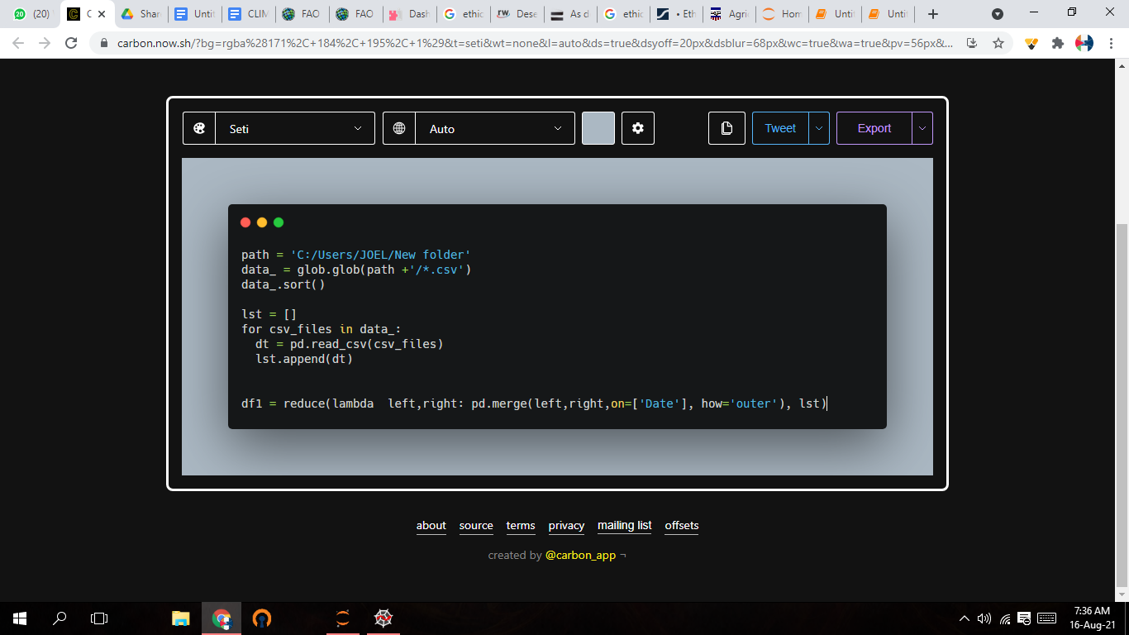

RAIFALL PATTERS I ETHOPI

**METHODS**

A time series of **36** counts of the months with rainfall values and monthly number of **0.05° × 0.05°** grid squares reported as infested with desert locust swarms, from **1981 to May 2021,** throughout the desert locust recession and invasion area was produced. The rainfall data scraped from the **CHIRPS** ([Climate Hazards Group InfraRed Precipitation with Station data](https://www.chc.ucsb.edu/data)) Rainfall data for African Daily and the swarms data was obtained from the **FAO SWARMS** dataset. No smoothing or interpolation was applied to the data, but missing rainfall values were replaced with zero(0). As phase changes, changes in the number of swarming locusts, can occur over much shorter periods. Data for the whole distribution area were modelled as one time series, as locusts are extremely migrating in nature and are able to travel many thousands of kilometres in a single generation (e.g. Magor et al. 2007 documented migration from Saudi Arabia to Mauritania). A time series data was formed by;

* For each X/Y (Lat/Long) point with country ID=Ethiopia, obtain the value of LocPresent for each date.
* For each day, a count (i.e. sum the 1s)(1s means Locust present) of the number of the grid points in the country (i.e square representing the country) where LocPresent is true was taken.
* So we get something like: (Datetime: 1/1/2000, LocPresent: 10) , (1/2/2000, 0), (1/3/2000, 50) etc.
* On this basis, Our time series data was formed.

This dataset is in daily interval, the dates of the object dataframe was parsed into datetime using the python datetime library. Squares where there are no rainfall values were replaced with zero. We didn’t implore the Nearest Neighbour interpolation because just a few squares points (lat/long) had no rainfall values(Rainfall values not present(-999999)).

Inorder to examine the influence of rainfall on desert locust populace, a time series interval of monthly rainfall and locust was calculated for, rather than a generation, the monthly data was chosen for this analysis. The datetime was resampled into a monthly number of **0.05° × 0.05°** grid squares, aggregating the rainfall and locust present values by taking it's sum. A count of **419** months were accounted for, with maximum and minimum value for the Rainfall Value being **1414.778174mm** and **0.000000mm** and that of the LocPresent being **496.000000** and **0.00000**. There are many grid squares where locusts have never been recorded breeding, and so it could be argued that the true breeding range of the species is mostly restricted to those squares where they have been known to breed. There are about **383** months with no rainfall values and **36** months with rainfall values, the months with no-rainfall values were dropped and analysis was carried out on the months with rainfall values.

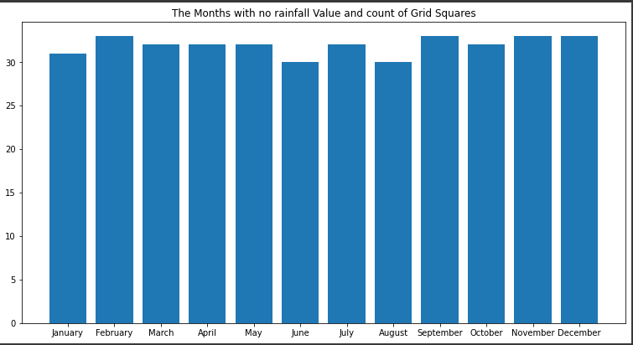

**Fig 3:** The number of months with no rainfall values (383 months).

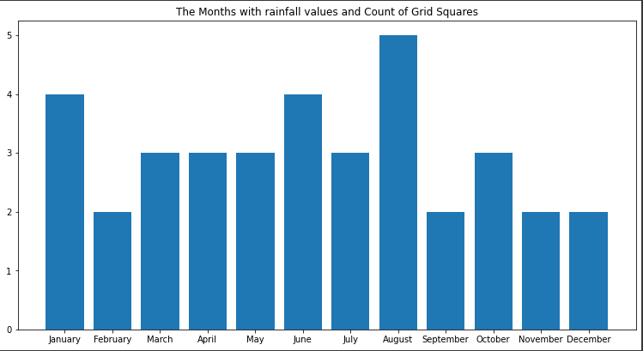

**Fig 4:** The number of months with rainfall values (36 months).

**Visualizing Rainfall and LocPresent Time Series Data**

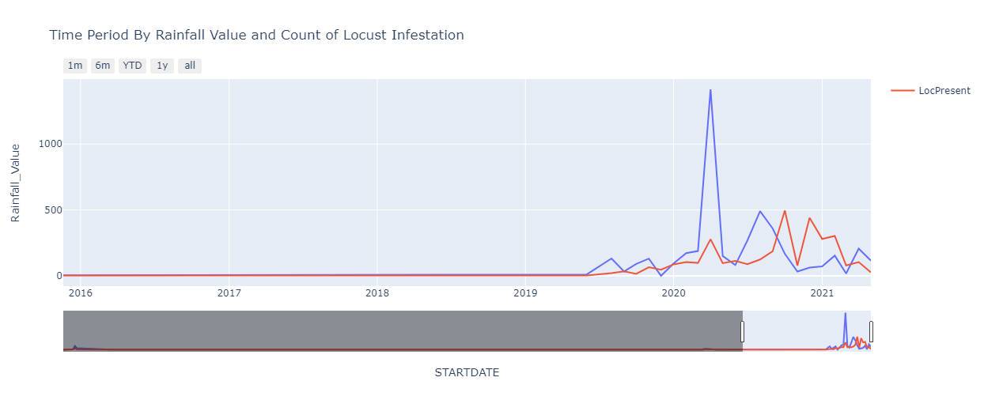

**Fig 5:** Lagged Rainfall Value and LocPresent value

Some distinguishable patterns appear when we plot the Lagged Rainfall Values with the Locust Present values, There seems to be drought, no much rainfall value and presence of locust from **1981** to around **2014**, and around **mid-2019** the rainfall and locust pattern started to rise, and around first-quarter of 2020 there was a spike in rainfall and this further gave the necessary breeding condition and environment for locust to lay eggs and breed, resulting in more recession and invasion in that area. From the plot we can see some evidence of seasonality from **mid-2019** to **May 2021**.

**Check for Stationarity**

Stationarity means that the statistical properties of a time series i.e. mean, variance and covariance do not change over time. Many statistical models require the series to be stationary to make effective and precise predictions. A check for Stationarity was carried out using the **Mean and Variance** and the **Augmented Dickey-Fuller Test.**

**Mean and Variance Check:**

* The stationarity and non-stationarity was checked by evaluating mean and variance in different time periods.
* Mean and Variance and other statistics of a Stationary time series remains constant, Hence, the conclusions from the analysis of stationary series is reliable.
* A stationary time series will not have trends, and seasonality,etc.

Stationary data is easier to analyze and any forecast made using non-stationary data would be erroneous and misleading.

**Augmented Dickey-Fuller test:**

Statistical tests make strong assumptions about your data. They can only be used to inform the degree to which a null hypothesis can be rejected or fail to be rejected. The result must be interpreted for a given problem to be meaningful.

* Nevertheless, they can provide a quick check and confirmatory evidence that your time series is stationary or non-stationary.
* The Augmented Dickey-Fuller test is a type of statistical test called a unit root test.
* The intuition behind a unit root test is that it determines how strongly a time series is defined by a trend.
* There are a number of unit root tests and the Augmented Dickey-Fuller may be one of the more widely used. It uses an autoregressive model and optimizes an information criterion across multiple different lag values.
* The null hypothesis of the test is that the time series can be represented by a unit root, that it is not stationary (has some time-dependent structure). The alternate hypothesis (rejecting the null hypothesis) is that the time series is stationary.
* **`Null Hypothesis (H0)`**: If failed to be rejected, it suggests the time series has a unit root, meaning it is non-stationary. It has some time dependent structure.
* **`Alternate Hypothesis (H1)`**: The null hypothesis is rejected; it suggests the time series does not have a unit root, meaning it is stationary. It does not have a time-dependent structure.
* We interpret this result using the p-value from the test. A p-value below a threshold (such as **5%** or **1%**) suggests we reject the **null hypothesis (stationary)**, otherwise a p-value above the threshold suggests we **fail to reject** the **null hypothesis (non-stationary)**.
* **`p-value > 0.05`**: Fail to reject the null hypothesis (H0), the data has a unit root and is non-stationary.
* **`p-value <= 0.05`**: Reject the null hypothesis (H0), the data does not have a unit root and is stationary.

The **LocPresent feature** data was splitted into halves to examine the mean and variance of the different time periods. 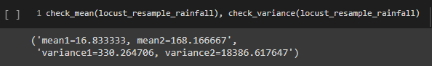

**Fig 6: Mean and Variance of the different time periods**

From the above, the mean and variance is not constant as examined in different time periods. Hence, the conclusion from the analysis of stationary series is reliable.

The next test for stationarity was carried out, the Augmented Dickey-Fuller test on the LocPresent Feature data.

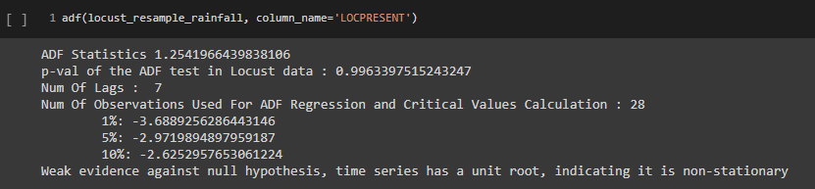

**Fig 7: ADF test of the LocPresent feature data**

The series has a unit root, which is weak evidence against the null hypothesis indicating that the series is non-stationary.

**Check for Autocorrelation function and Partial Autocorrelation function**

Autocorrelation refers to the degree of correlation of the same variables between two successive time intervals. It measures how the lagged version of the value of a variable is related to the original version of it in a time series. Autocorrelation, as a statistical concept, is also known as serial correlation. The **partial autocorrelation function (PACF)** gives the partial correlation of a stationary time series with its own lagged values, regressing the values of the time series at all shorter lags. It contrasts with the autocorrelation function, which does not control for other lags. The **ACF plot** is merely a bar chart of the **`coefficients of correlation`** between a **`time series`** and **`lags of itself.**` The **`PACF plot`** is a plot of the **`partial correlation coefficients`** between the **`series`** and **`lags of itself`**. Thus, the value for the **`ACF`** and the **`PACF`** at the first lag are the same because both measure the **`correlation`** between data points at **`time t`** with data points at **`time t − 1`.**

* **Autocorrelation function (ACF).** At lag k, this is the correlation between series values that are k intervals apart.
* **Partial autocorrelation function (PACF)**. At lag k, this is the correlation between series values that are k intervals apart, accounting for the values of the intervals between.
* A positive correlation indicates that large current values correspond with large values at the specified lag; a negative correlation indicates that large current values correspond with small values at the specified lag.
* The absolute value of a correlation is a measure of the strength of the association, with larger absolute values indicating stronger relationships.

We checked for the autocorrelation function and partial autocorrelation of the LocPresent Feature of the Locust data. A 25 month lag of ACF and PACF was used for this, This was implemented using some helper functions.

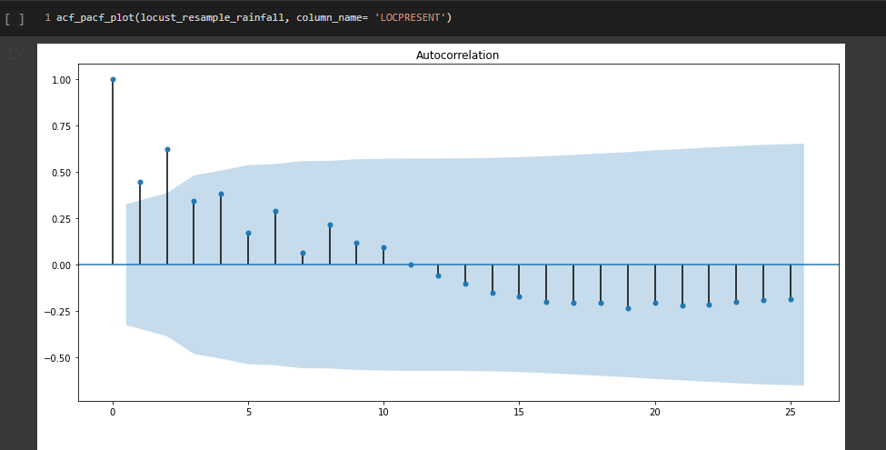

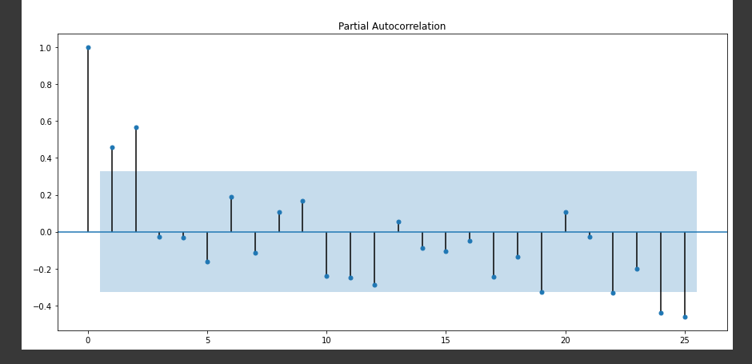

**Fig 8: ACF and PACF of the LocPresent feature of the Locust data.**

The x axis of the ACF plot indicates the lag at which the autocorrelation is computed; the y axis indicates the value of the correlation (between −1 and 1). For example, a spike at lag 1 in an ACF plot indicates a strong correlation between each series value and the preceding value, a spike at lag 2 indicates a strong correlation between each value and the value occurring two points previously, and so on.

* The Blue line represents the significant thresholds.
* Vertical lines that fall under the blue lines are not statistically significant and vice versa.

The **ACF** measures the correlation between values at each point in a series and values at lags prior to that point (Box & Jenkins 1976, Diggle 1990, Chatfield 1997). This information is further used to calculate the **PACF**, the correlation remaining between each point and lag in the series after the influences of all closer lags have been removed.

**Data Transformation:**

Square-root transformation of the locust data was carried out which would be used for the models to achieve equality of variance and a normal distribution. The varying mean and Variance of the square-root transformed locust data was examined as well as the **Augmented Dickey-Fuller test**. A 25 month lag of the ACF of this Square-root transformed time locust series showed a high degree of autocorrelation.

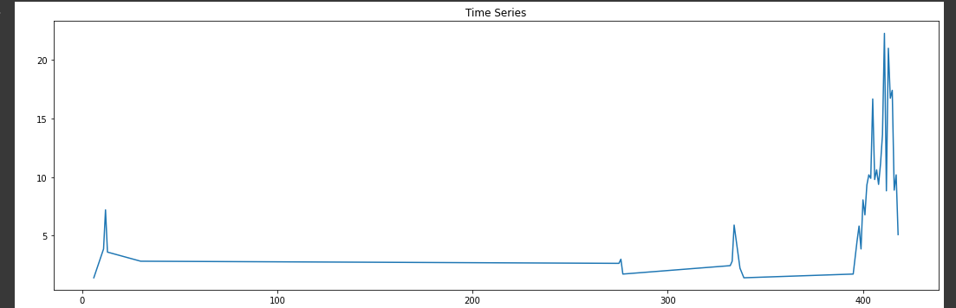

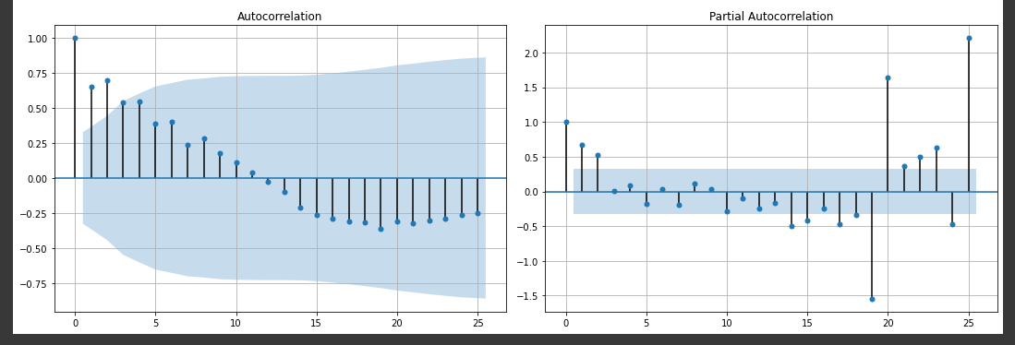

**Fig 9: acf and pacf of the square-root transformed LocPresent locust data**

**Differencing**

Differencing is a method of transforming a non-stationary time series into a stationary one. This is an important step in preparing data to be used in an ARIMA model. This shows one way to make a non-stationary time series stationary, by computing the differences between consecutive observations.

First-Order Differencing:

The first difference of a time series is the series of changes from one period to the next. If **Yt** denotes the value of the time series **Y** at period **t**, then the first difference of **Y** at period **t** is equal to **Yt-Yt-1**. The first differencing value is the difference between the current time period and the previous time period.

* The first-Order differencing of the **Square-root transformed** locust data was taken and Stationarity was checked and had no unit root and is stationary.

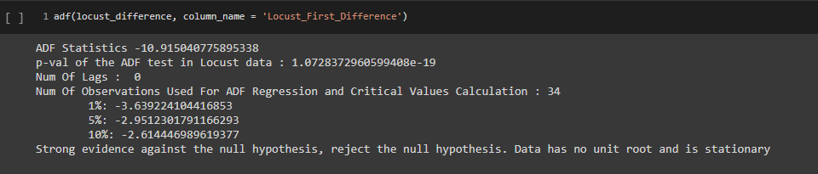

**Fig 10: ADF test of the Square-root transformed LocPresent Locust data**

* The **ACF** and **PACF** were plotted using the values of the first difference locust data.

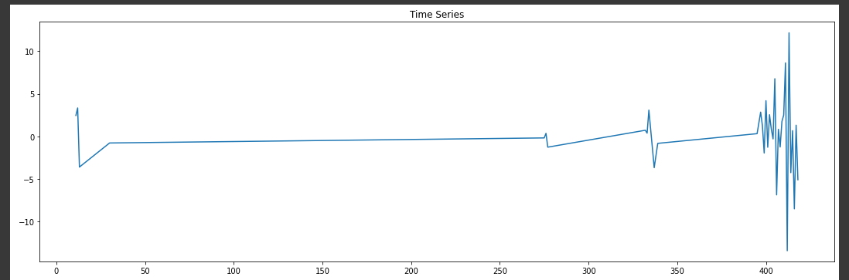

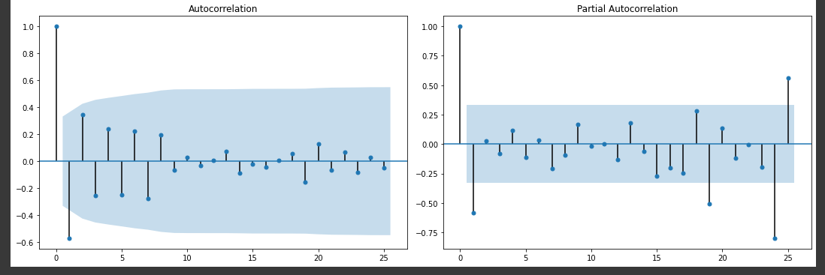

**Fig 11: ACF and PACF plot of the First difference Locust data**

* Calculating the first order differencing of a time series is useful for converting a non stationary time series to a stationary form.
* It is calculated as follows. The **i-th**data point **Y_i** of a time series is replaced by

**Y'_i = (Y_i - Y_(i-1).**

**Seasonal differencing**

A seasonal difference is the difference between an observation and the previous observation from the same season. So

***y!t == yt - yt-m***

where ***m***=the number of seasons. These are also called ***“lag- m differences,”*** as we subtract the observation after a lag of ***m*** periods. Sometimes it is necessary to take both a seasonal difference and a first difference to obtain stationary data. Here, the data are first transformed using square-root transformation, first differencing was carried out, then seasonal difference was carried out on the output of the first differencing.

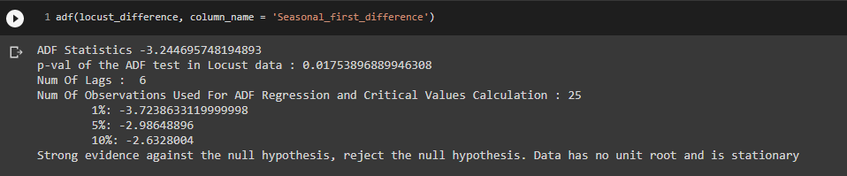

**Fig 12: ADF test of the Seasonal difference locust data.**

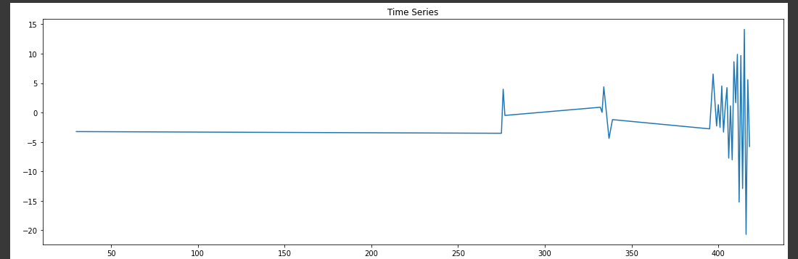

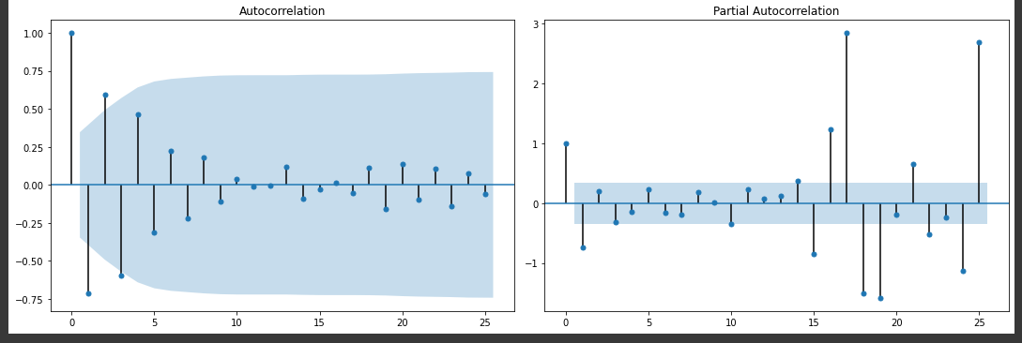

**Fig 13: ACF and PACF plot of the Seasonal difference locust data.**

The right order of differencing is the minimum differencing required to get a near-stationary series which roams around a defined mean and the ACF plot reaches to zero fairly quickly. If the autocorrelations are positive for many numbers of lags (10 or more), then the series needs further differencing. On the other hand, if the lag 1 autocorrelation itself is too negative, then the series is probably over-differenced.

**Modeling**

The model building and selection strategy was to derive purely endogenous ARIMA models of the series and to examine the effect of adding lagged rainfall data as exogenous variables. ARIMA models of the series were selected on the basis of an examination of autocorrelation and partial autocorrelation functions (ACF and PACF, respectively) using standard techniques. An ARIMA model consists of a forecasting equation which may include previous lags in the series, or ‘autoregressive’ terms, and lags of the forecast errors, or ‘moving average’ terms.

A time series which needs to be differenced to be made stationary is said to be an ‘integrated’ version of a stationary series (Box & Jenkins 1976). The notation used to describe an ARIMA model is of the form **(p d q)(P D Q)S**. The first set of parentheses represents the **non-seasonal** part of the model, with **p** the order of an autoregressive process, **d** the order of differencing and **q** the order of a moving average process. The second set of parentheses represents the **seasonal component**, where **P** is the order of a seasonal autoregressive process, **D** the order of seasonal differencing and **Q** the order of a seasonal moving average process. **S** represents the length of the seasonal period (Diggle 1990, Chatfield 1997).

The **ARIMA** Model

**ARIMA**, short for **‘AutoRegressive Integrated Moving Average**’, is a forecasting algorithm based on the idea that the information in the past values of the time series can alone be used to predict the future values. The **Seasonal Autoregressive Integrated Moving Average, SARIMA** or Seasonal ARIMA, is an extension of ARIMA that explicitly supports univariate or multivariate time series data with a seasonal component.

An ARIMA model is characterized by 3 Trend effect terms: **p, d, q**, where,

* **p** is the order of the **AR** term (autoregression order)
* **q** is the order of the **MA** term (moving average order)
* **d** is the number of differencing required to make the time series stationary. (difference order).

Any ‘**non-seasonal**’ time series that exhibits patterns and is not a random white noise can be modeled with ARIMA models, which is actually a class of models that ‘explains’ a given time series based on its own past values, that is, its own lags and the lagged forecast errors, so that equation can be used to forecast future values.

The SARIMA model been an extension of the ARIMA model has four seasonal elements that are not part of ARIMA that must be configured; they are:

* **P**: Seasonal autoregressive order.
* **D**: Seasonal difference order.
* **Q**: Seasonal moving average order.
* **S**: The number of time steps for a single seasonal period. For example, an S of 12 for monthly data suggests a yearly seasonal cycle.

SARIMA notation: **SARIMA (p,d,q) (P,D,Q,S)**

**AR(p)** : autoregression model i.e. regression of the time series onto itself. The basic assumption is that the current series values depend on its previous values with some lag (or several lags). The maximum lag in the model is referred to as p . To determine the initial p, you need to look at the **PACF** plot and find the biggest significant lag after which most other lags become insignificant.

**MA(q):** moving average model. Without going into too much detail, this models the error of the time series, again with the assumption that the current error depends on the previous with some lag, which is referred to as q. The initial value can be found on the **ACF** plot with the same logic as before. Let's combine our first 4 letters:



What we have here is the **Autoregressive–moving-average model**! If the series is stationary, it can be approximated with these 4 letters.

**I(d):** order of integration. This is simply the number of non-seasonal differences needed to make the series stationary. Adding this letter to the four gives us the ARIMA model which can handle non-stationary data with the help of non-seasonal differences.

**S(s):** this is responsible for seasonality and equals the season period length of the series With this, we have three parameters: **(P,D,Q).**

**P:** order of autoregression for the seasonal component of the model, which can be derived from **PACF**. But you need to look at the number of significant lags, which are the multiples of the season period length.

**D:** order of seasonal integration. This can be equal to 1 or 0, depending on whether seasonal differences were applied or not.

**RESULTS**

The modelling techniques developed were not analysed mechanistically in relation to a multitude of variables such as vegetation, density and condition, soil types, temperature and hydrology. We were interested in seeing what could be concluded from time series analyses of the locust data and then in testing whether inclusion of the main factor in locust survival, i.e. rainfall, improved the predictive power of phenomenological models derived from the time series analyses.

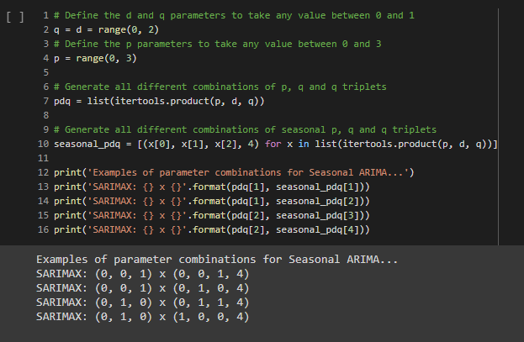

**Fig 14: Grid Search parameter selection.**

Parameter Selection for our **S(ARIMA)** Time Series Model. The goal here is to use a “**grid search**” to find the optimal set of parameters that yields the best performance for our model.

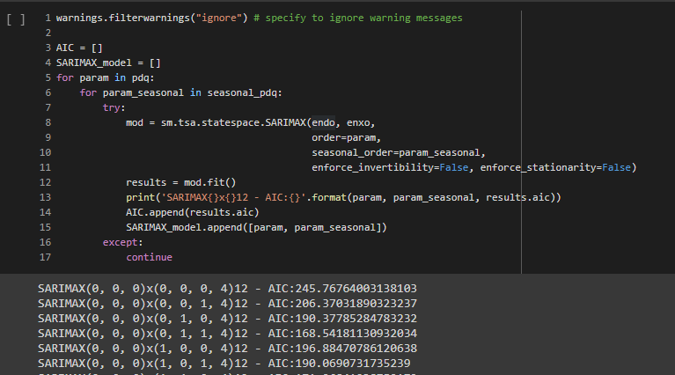

**Fig 15: Grid Search parameters selection Output.**

The Grid Search output suggests that **`SARIMAX(2, 1, 0)x(2, 1, 0, 4)12**` yields the **`lowest AIC**` value of `**AIC:132.0736131874681**`. Therefore we should consider this to be the optimal option.

**AIC** and **BIC** are widely used in model selection criteria. AIC means **Akaike’s Information Criteria** and BIC means **Bayesian Information Criteria**. The AIC and BIC are not used to test the model in the sense of hypothesis testing, but for model selection. Given a data set, a researcher chooses either the AIC or BIC, and computes it for all models under consideration. Then, the model with the lowest index is selected. AIC can be termed as a measure of the goodness of fit of any estimated statistical model. The BIC is a type of model selection among a class of parametric models with different numbers of parameters. The BIC is calculated as **–2ln(L) + ln(n)k**, where L is the likelihood function based on the residuals from the model, n is the number of residuals and k is the number of free parameters (Schwarz 1978, Wei 1990). This value therefore takes into account both the fit of the model and its parsimony, and should be as low as possible.

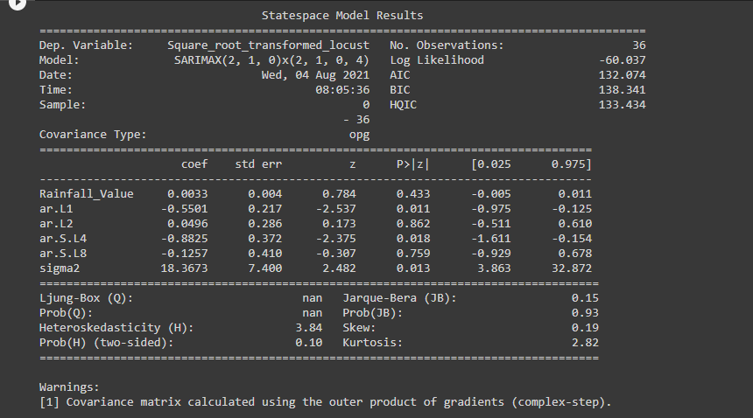

**Fig 16: Model Summary Output.**

**Fitting the Model**

The Model training, using the **statsmodels.tsa.statespace.sarimax**  , where we passed the LocPresent as our endogenous variable and the Rainfall value as exogenous variable.

“Endogenous Variables are input variables that are influenced by other variables in the system and on which the output variable depends, while Exogenous variables are input variables that are not influenced by other variables in the system and on which the output variable depends. An exogenous variable is a variable that is not affected by other variables in the system. For example, take a simple causal system like farming. Variables like weather, farmer skill, pests, and availability of seed are all exogenous to crop production.”

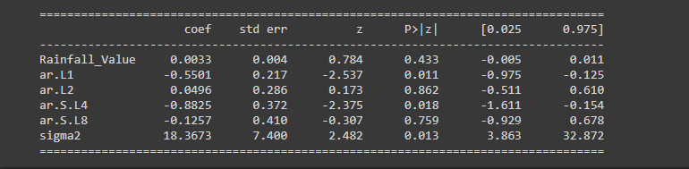

**Fig 17: Model Summary Table**

The non-seasonal order of the model training was given as **order=(2,1,0),** and the seasonal order as **seasonal_order=(2,1,0,4),** the model was trained and fitted given these variables and values.

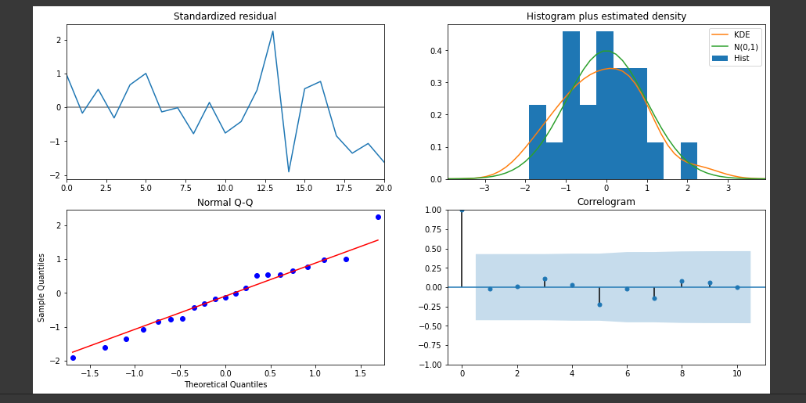

**Fig 18: Model diagnostics.**

This is not perfect, however, our model diagnostics suggests that the model residuals are near normally distributed.

**Predictions of the model (Validating forecast)**

To test the predictive power of the models, forecasts for the square-root-transformed locust series were produced for the period **2009-06-01' to '2021-05-01**. This model did not use any locust data after 2009 but did use the rainfall series (exogenous variable) from 2009–2021 as an input to the forecast for this period.

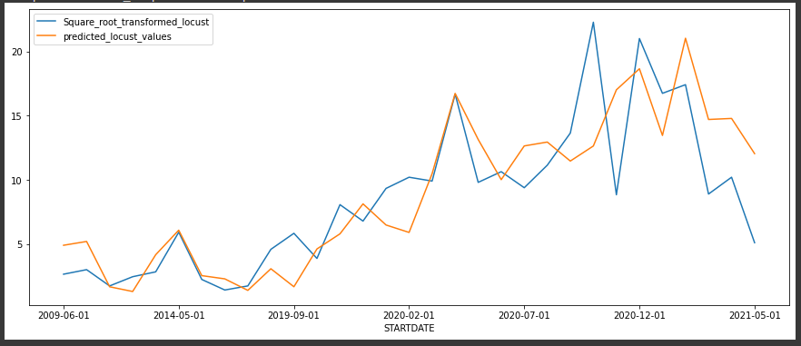

**Fig 19: The line plot showing the Square-root transformed locust values compared to the predicted locust values.**

The line plot is showing the observed values compared to the forecast predictions. Overall, our forecasts are not very well aligned with the true values, but not too bad per say, showing the upward trend that started from 2019.

**Mean Squared Error and Root Mean Squared Error.**

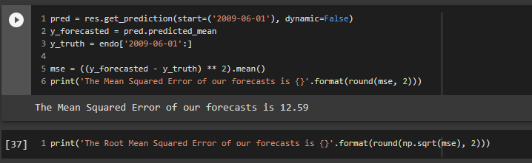

**Fig 20: the mean squared error and root mean squared error.**

- In statistics, the mean squared error (MSE) of an estimator measures the average of the squares of the errors — that is, the average squared difference between the estimated values and what is estimated. The MSE is a measure of the quality of an estimator — it is always non-negative, and the smaller the MSE, the closer we are to finding the line of best fit.

- Root mean squared error (RMSE) is the square root of the mean of the square of all of the errors. The use of RMSE is very common, and it is considered an excellent general-purpose error metric for numerical predictions.

**CONCLUSION DRAWN (DISCUSSION)**

Desert locust requires adequate rain at sites where their egg-pods have been laid to allow hatching and, if rainfall has been sufficiently high, the hatching will coincide with flushes of green vegetation for them to feed on. In consequence, there has been extensive research on the causes of outbreaks such as relations between rainfall patterns and desert locust upsurges. From this analysis we got to know that changes in rainfall determine locust breeding (proximate causes). Some regional studies have sought patterns that could be used for forecasting. In this study we were able to examine whether drivers of these changes in rainfall (Climate Change) are themselves correlated with locust abundance (ultimate causes).

Although this analysis did not examine precise mechanisms driving changes in abundance, the modelling approach used here has identified the key roles of both endogenous factors and rainfall in determining the size of the region occupied by locust swarms bands across the entire range of the species. As a result, it offers hope for the better prediction of the effect of future changes in rainfall patterns(Climate Change) on the locust problem, which are limiting to examining locust upsurges arising under specific circumstances over relatively small, albeit important, areas (East Africa) of the breeding range of the species.  
 The inclusion of the exogenous variable (rainfall value) improved the fit of the S(ARIMA) model; this analysis has clearly shown that desert locust population dynamics at a global scale are at least partly driven by climate change (rainfall). However, as the time step was only one(1) month, which is less than the generation time of the locusts, autocorrelation at lag 1, and perhaps lags 2 to 3, would be expected. An examination of the line plot does show that our model incorporating rainfall data can predict upsurges and declines with some degree of success. Using a square-root transformation on the data also tended to increase the degree of first-order autocorrelation and reduced the degree to which more remote lags were found to be significant in autocorrelation analysis. This indicates that at relatively high abundance upward or downward shifts in numbers tend to be greater than at low population levels. FAO has already stated that the pest outbreak is an ‘unprecedented threat’ to food security and livelihoods in those regions that are already vulnerable to climate change. Similarly, these locust outbreaks also depend on climate change as they require moist soil for egg incubation, they prefer to migrate to those areas where recent rainfall has occurred in order to get plenty of green vegetation to feed and breed. So the region with exceptional weather events due to climate change becomes more susceptible and gets heavy damage by locust swarms outbreak.

Furthermore, these swarms are getting more prevalent in the present context due to increase in deforestation, industrialization, urbanization and all other human activities which increase greenhouse gases mainly methane and carbon dioxide on earth. This increased concentration of carbon dioxide gases results in enhancement of rainfall, soil moisture level, vegetation growth which increases the size of the locust swarm and its outbreak frequencies. Moreover, from autocorrelation analysis and autoregressive integrated moving average (ARIMA) analysis it has been found that endogenous factors and rainfall play an important role in determining the size of the territory occupied by locust swarms across the entire range of the species (Tratalos et al., 2010). This analysis suggests that desert locust dynamics are influenced by endogenous factors and rainfal, and that broad patterns of locust upsurges and declines can be forecast with some degrees of success using data on only this factors.

It should be known that the locust data analysed here are based on coverage of lat/long areas infested by locust swarms in Ethiopia region, other areas and regions(countries) infested by locust were no analysed but since locust swarms behave and move in gregarious pattern, whatever notion or conclusion drawn from the analysis of Ethiopia region should also hold for the other regions if all elements that contribute to it’s breeding and movement remain same. Furthermore, the time series analysed are not a direct measure of the locust abundance, but rather indicate the area that they covered during a given month in Ethiopia region, and it should be borne in mind that sampling error may confound the results of ARIMA modelling. These factors should be taken into account when interpreting the results of the analysis.

**AREAS OF IMPROVEMENTS**

Locust Swarms and hopper bands are conspicuous events, likely to be reported by local people and observed by locust survey and control personnel, solitarious locusts will often have gone unnoticed. There was no or low value in rainfall and locust swarms in some months from early 1990 to late 2015, and the months without rainfall values were removed and weren't accounted for during the modelling with SARIMA as this model takes account of the seasonal patterns in each period. Missing rainfall values were replaced with zero, this is because there were just two regions that had these missing rainfall values, the ideal approach is to use spatial interpolation to replace those missing values. Resampling the data to the monthly grid involved taking the sum of each locust and rainfall value for each grid, another approach would be to take the average rainfall and locust value to observe if this would give a better performance. Another approach to check for Stationarity is the **KPSS (Kwiatkowski–Phillips–Schmidt–Shin)** test, as we used the **ADF** in our analysis. It is always better to apply both the tests, so that it can be ensured that the series is truly stationary. Possible outcomes of applying these stationary tests are as follows:

* **Case 1:** Both tests conclude that the series is not stationary - The series is not stationary.
* **Case 2:** Both tests conclude that the series is stationary - The series is stationary.
* **Case 3:** KPSS indicates stationarity and ADF indicates non-stationarity - The series is trend stationary. Trend needs to be removed to make the series strictly stationary. The detrended series is checked for stationarity.
* **Case 4:** KPSS indicates non-stationarity and ADF indicates stationarity - The series is difference stationary. Differencing is to be used to make series stationary. The differenced series is checked for stationarity.

Two tests for checking the stationarity of a time series are used, namely **ADF test** and **KPSS test**. Detrending is carried out by using differencing. Trend stationary time series is converted into strict stationary time series. Requisite forecasting model can now be applied on a stationary time series data. Also, once predictions of likely climate climate changes throughout the recession area can be

made with more confidence than at present, our results could be helpful in forecasting whether locust plagues will become more or less frequent. For instance, if the forecasts of increased precipitation over important desert locust habitats in the Sahara along a west–east belt at about 20°N on the basis of the AB1 scenario (Hulme et al. 2001) are realised, then locust upsurges are likely to become more frequent.

**LITERATURE CITED**

* <https://en.wikipedia.org/wiki/Desert_locust>
* <https://web.archive.org/web/20150408034918/http://ipmworld.umn.edu/chapters/showler.htm>
* <http://www.nzdl.org/gsdlmod?e=d-00000-00---off-0hdl--00-0----0-10-0---0---0direct-10---4-------0-1l--11-en-50---20-about---00-0-1-00-0-0-11-1-0utfZz-8-10-0-0-11-10-0utfZz-8-00&a=d&c=hdl&cl=CL1.10&d=HASHd1edbf77fbe3fa2e5e3da5.4.2>
* <https://doi.org/10.1111%2Fj.1469-185x.1999.tb00038.x>
* <https://en.wikipedia.org/wiki/S2CID_(identifier)>
* <https://api.semanticscholar.org/CorpusID:86261709>
* <http://www.fao.org/newsroom/en/focus/2006/1000345/>
* <https://en.wikipedia.org/wiki/Food_and_Agriculture_Organization>
* <http://www.differencebetween.net/miscellaneous/difference-between-aic-and-bic/>
* <https://www.ibm.com/docs/en/spss-modeler/SaaS?topic=data-autocorrelation-partial-autocorrelation-functions>
* <https://www.sciencedirect.com/topics/medicine-and-dentistry/akaike-information-criterion>
* <https://www.researchgate.net/publication/235343807_Desert_locust_populations_rainfall_and_climate_change_Insights_from_phenomenological_models_using_gridded_monthly_data>